**Project Report**

**Title:** The ecommerce_django-main-vishal.zip code will be given in the project report.

**Course:** AWS

**Student Name:** Laxman

**Objective**

To develop and host a Django-powered website on AWS, leveraging VPC for secure, isolated networking, ensuring efficient, reliable, and scalable delivery of web hosting services to end users.

**Configuration Details**

**Creating the AWS Console account**

**Requirements:** **1) Gmail ID**

**2) Phone no**

**3) Residential Address**

**4) Debit Card International Payment Ke Liye**

**5) Pen Card**

**Steps Performed**

**Step1:** **1)** **Open the any browser**

1. **Search AWS**

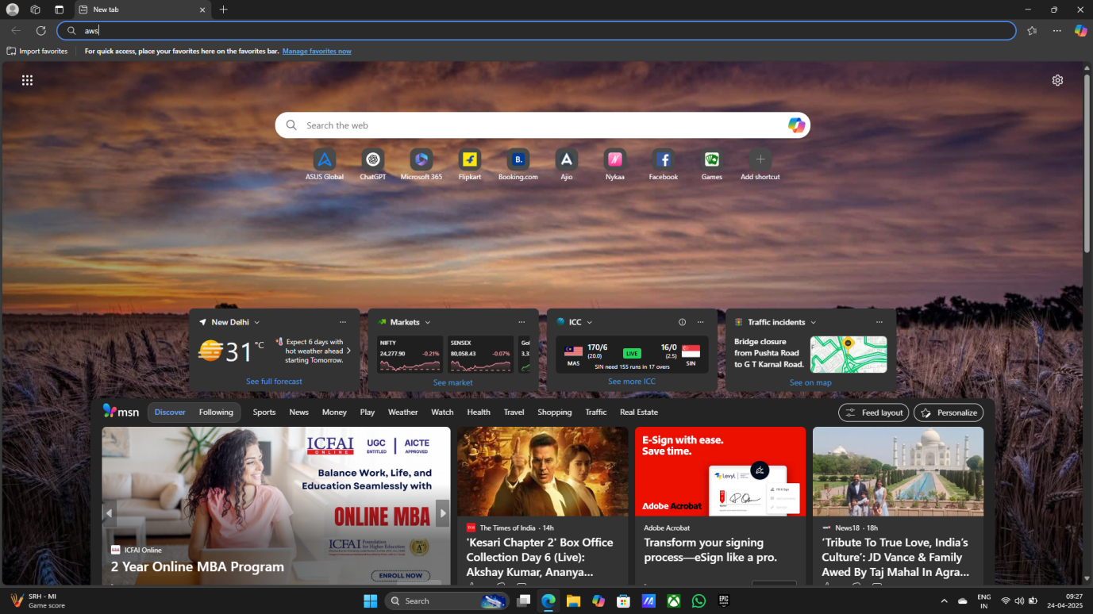

1. **Open the First Link**

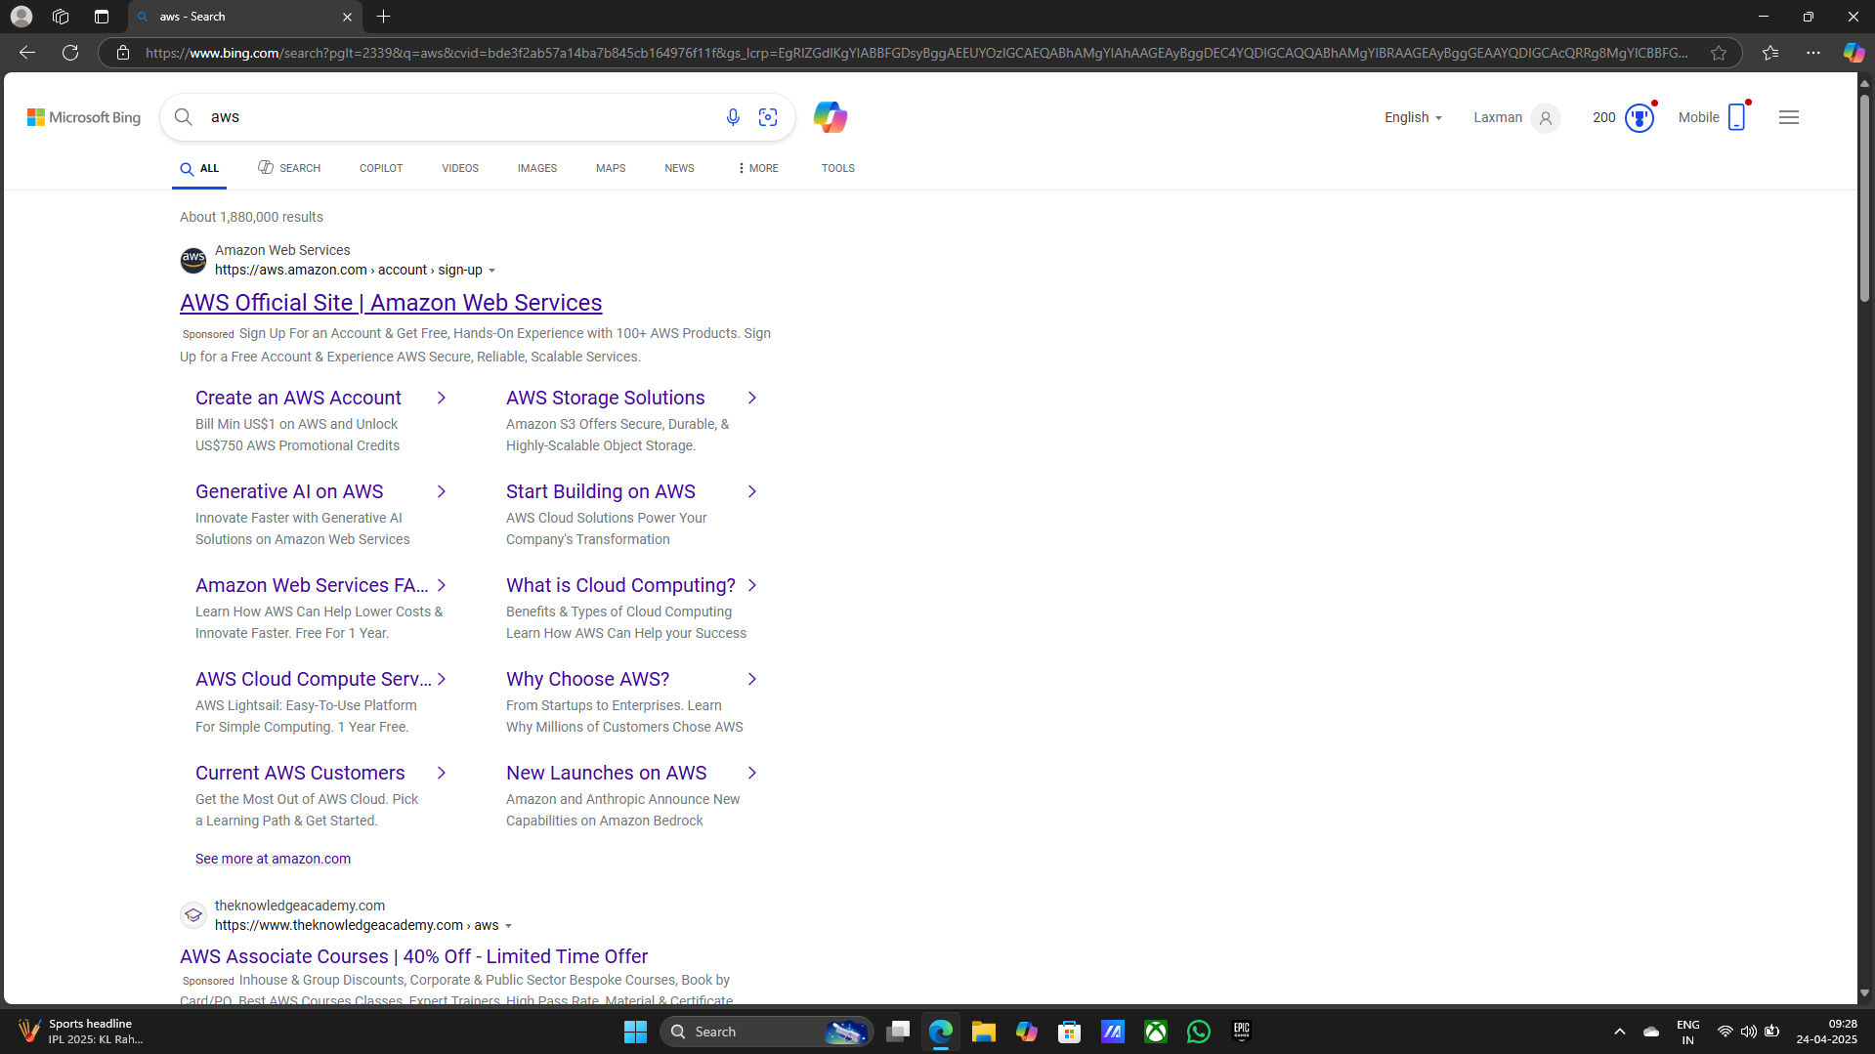

1. **Sign in to the console**

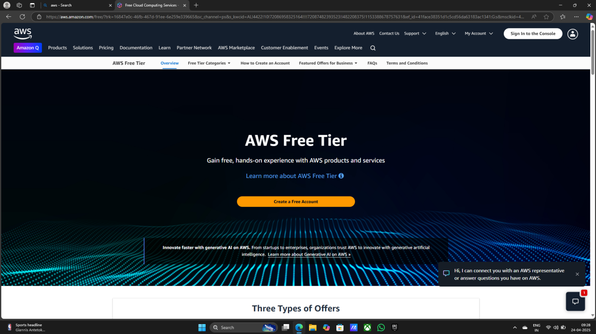

**Step2: 1) Search VPC on search bar**

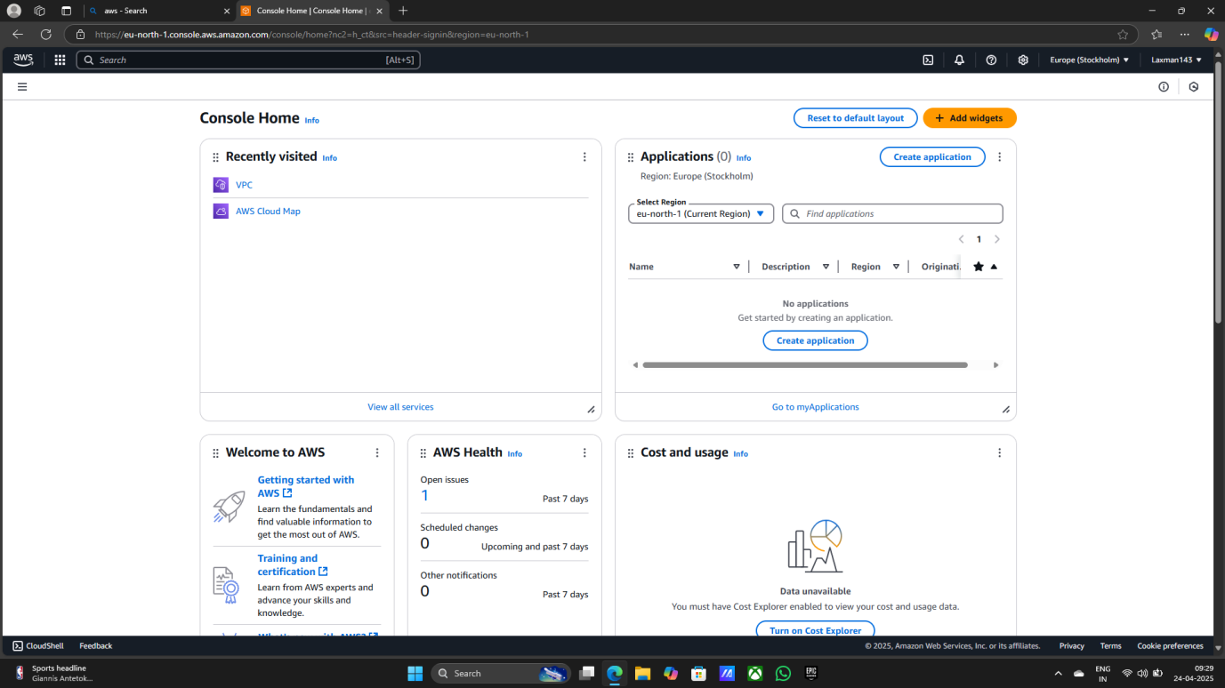

1. **Click on VPC**

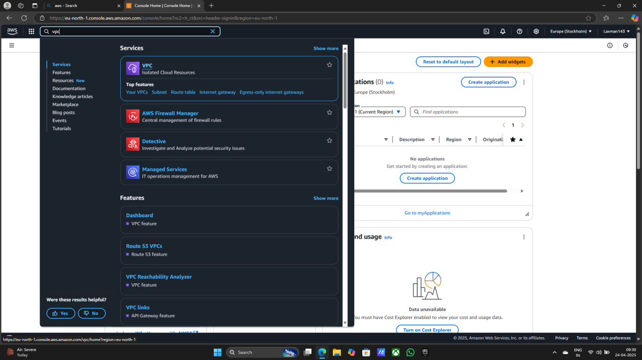

1. **First Your VPCs**

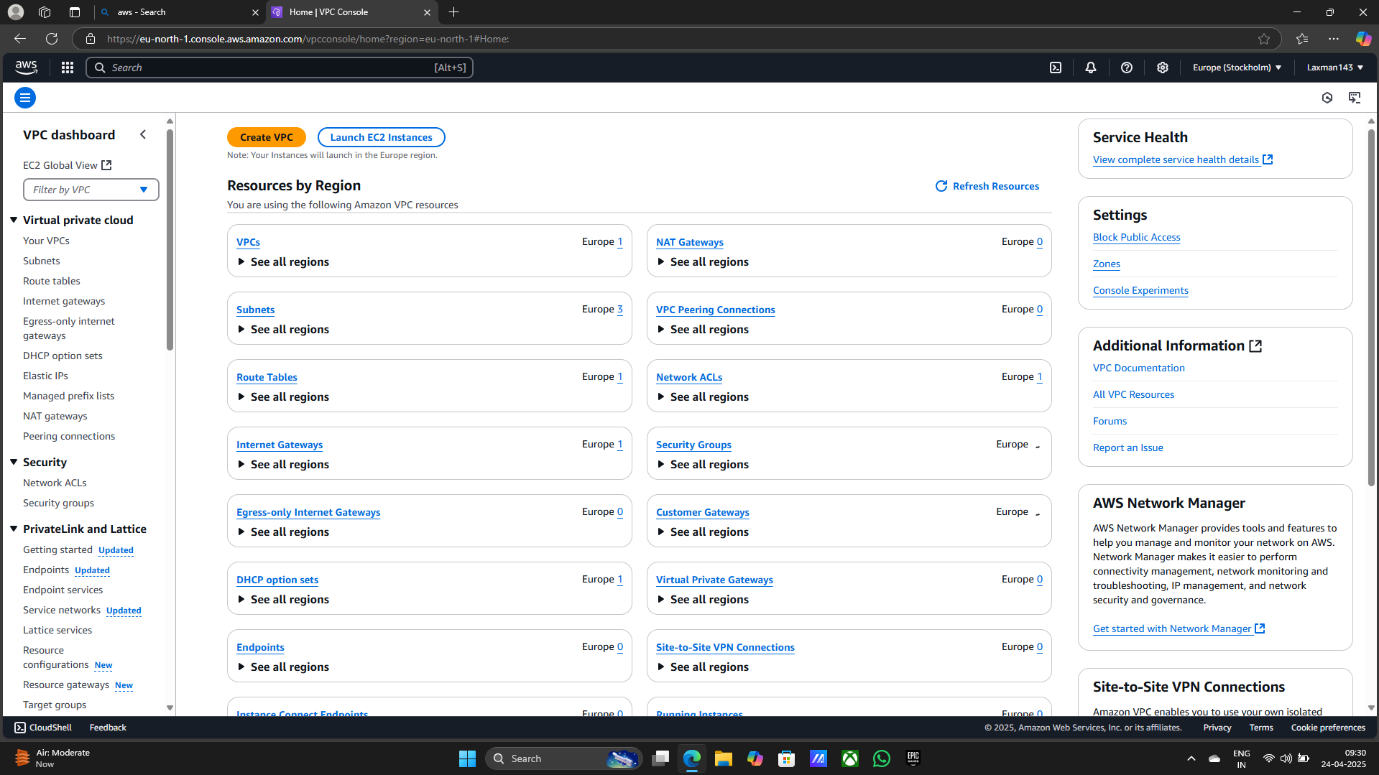

1. **Creating Your VPCs**

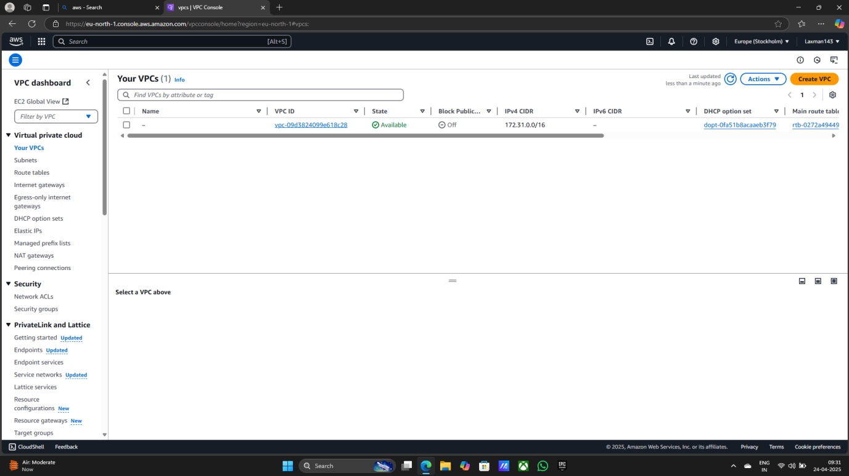

**> Select VPC only**

**> my-vpc-01**

**> 192.168.0.0/24**

**> Default**

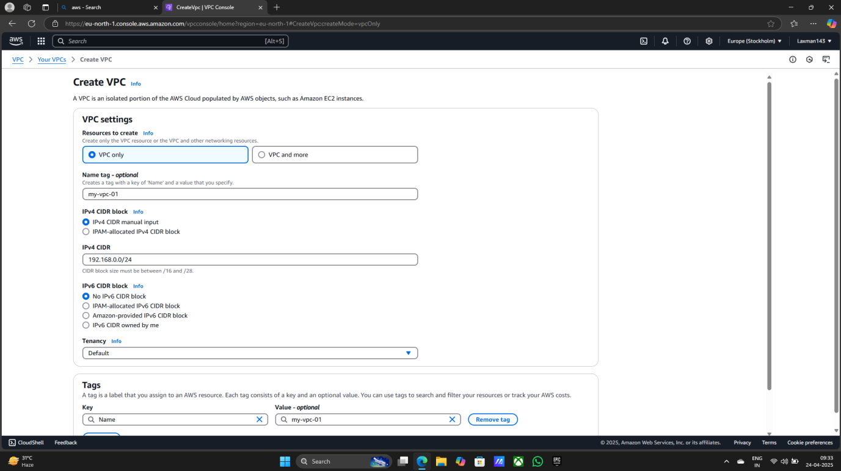

**> Create VPC**

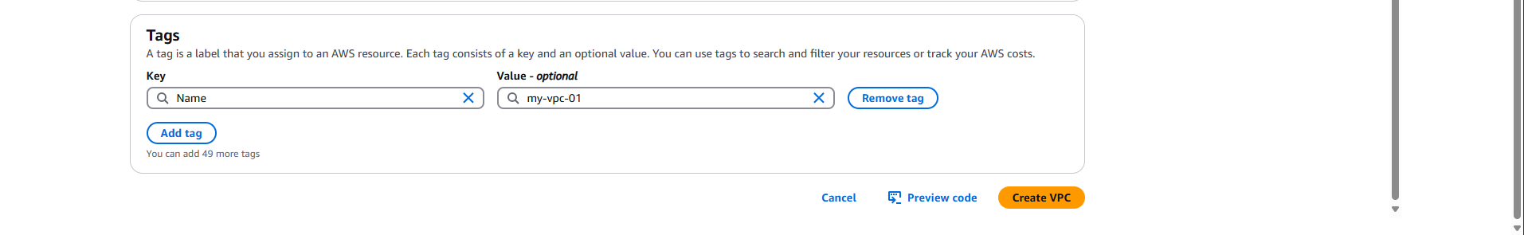

**Step3: 1) Second Subnets**

**> Create subnet**

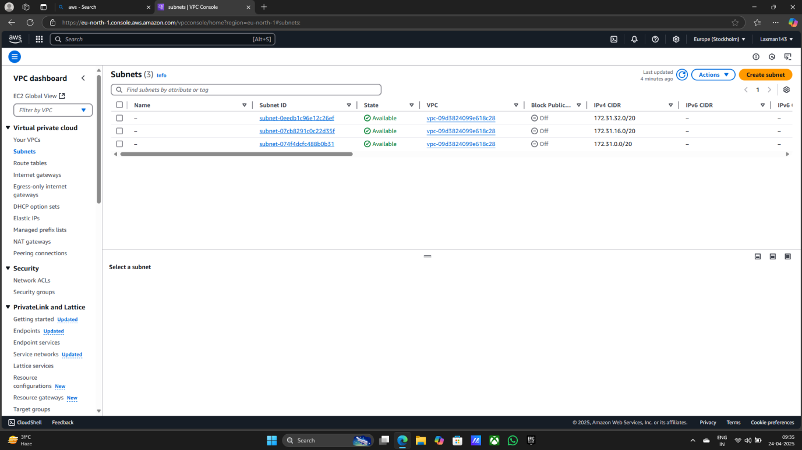

1. **Creating two Subnets**
2. **pubsub (Public subnet)**
3. **prtsub (Private subnet)**

**> Select Created VPC ID**

**> pubsub**

**> 192.168.0.1/25**

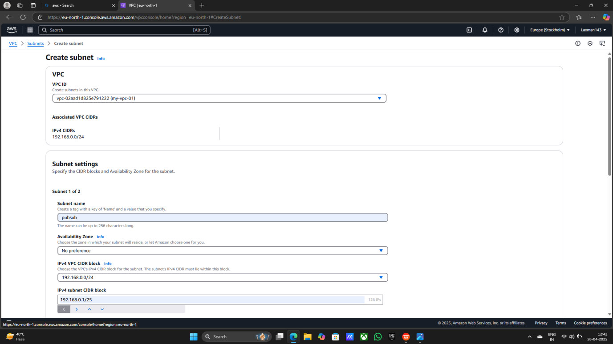

**> prtsub**

**> 192.168.0.128/26**

**> continue to create subnets**

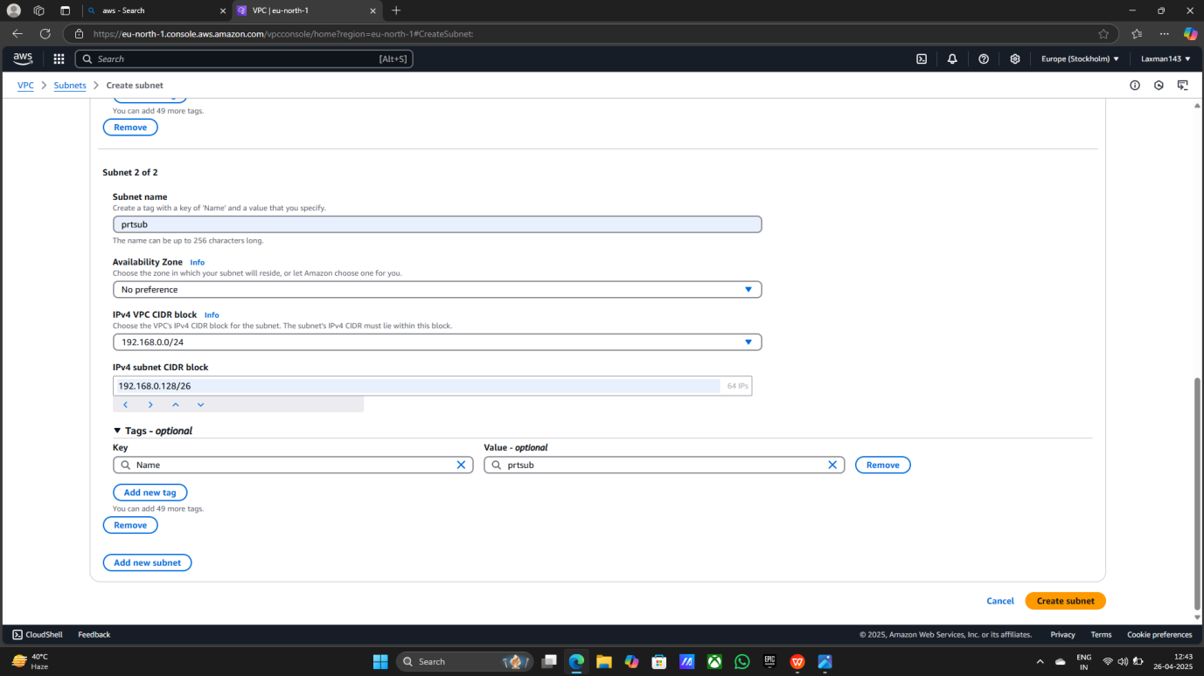

**Step4: 1) Third Route tables**

**> Create route table**

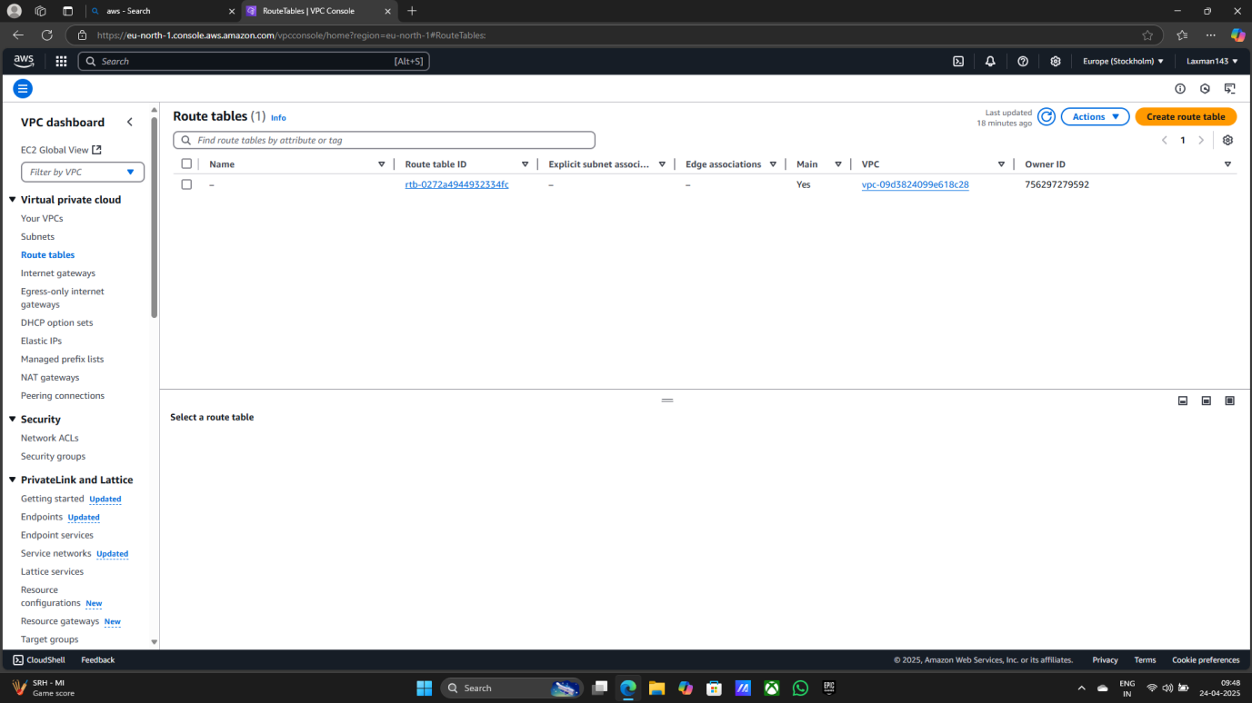

1. **Creating Route tables**

**> Created two route tables (pubrt , Prtrt)**

**> pubrt (Public Route Table)**

**> Select VPC**

**> Create Route table**

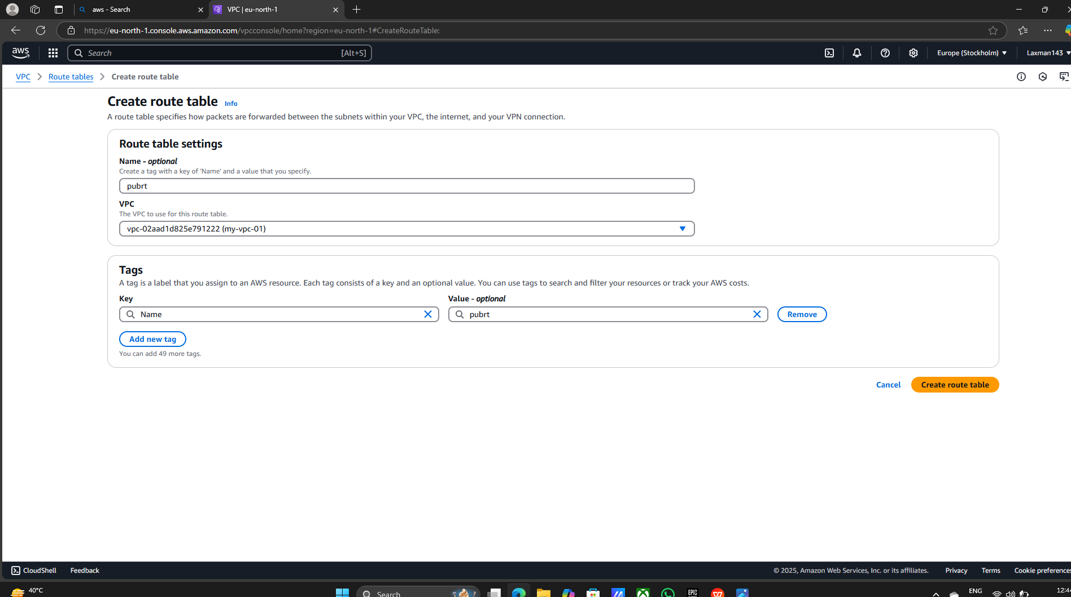

**> prtrt (Private Route Table)**

**> Select VPC**

**> Create Route table**

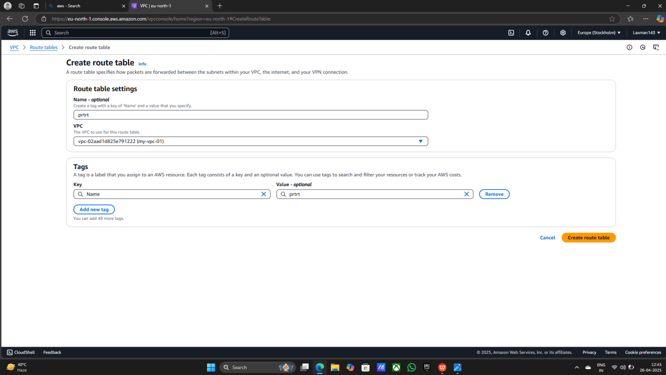

**> Public and Private Route table is created successfully**

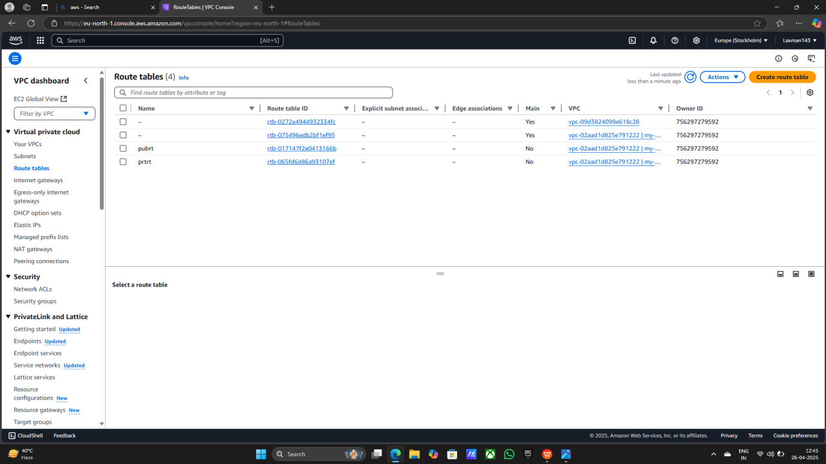

**> Entry of Public Route Table in subnet associations**

**> Select Public Route Table**

**> Click on subnet associations**

**> Click on Edit subnet associations**

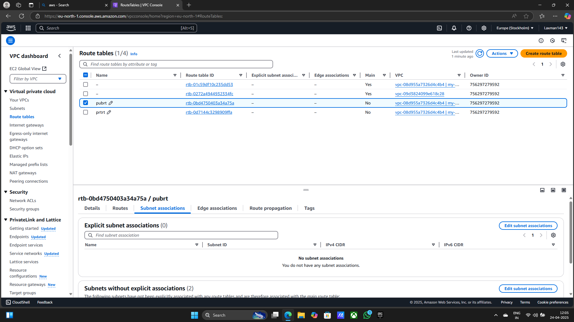

**> Select pubsub**

**> Save associations**

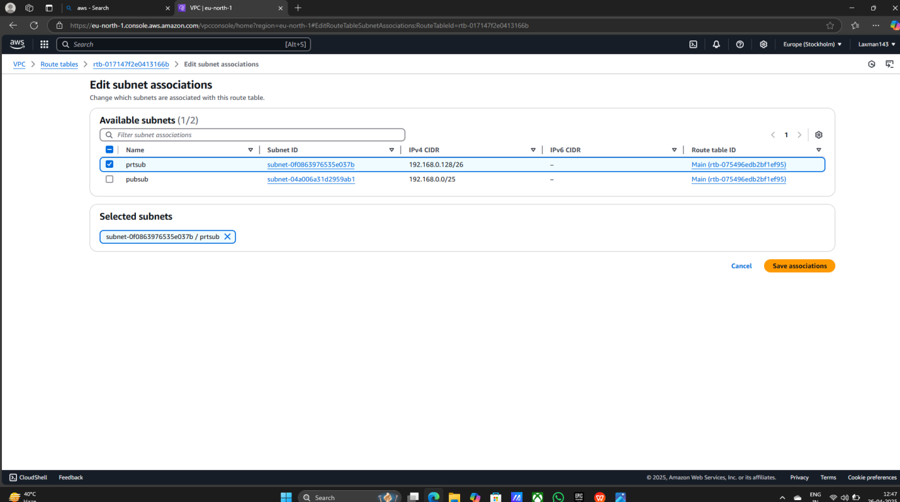

**> Entry of Public route table in routes**

**> Select pubrt**

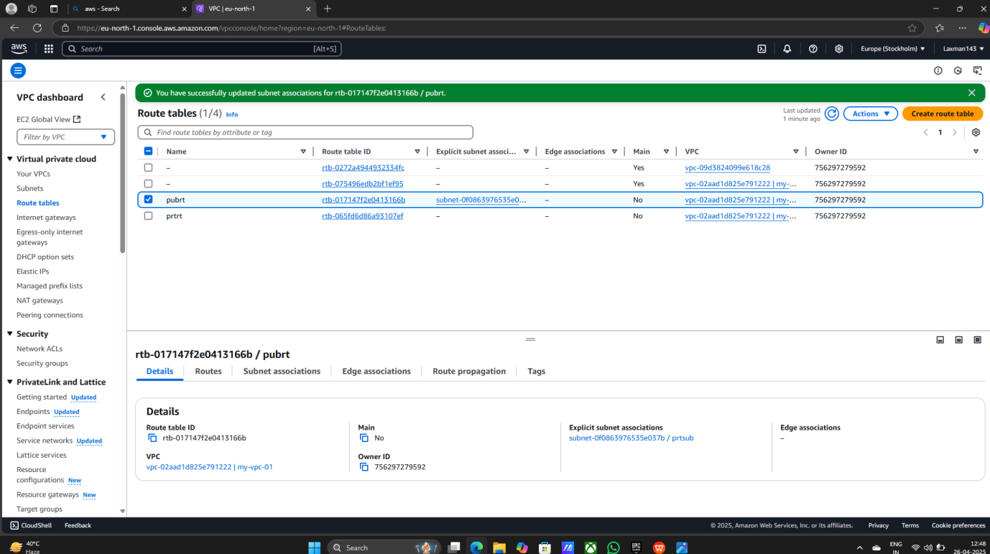

**> Click on routes**

**> Click on Edit Routes**

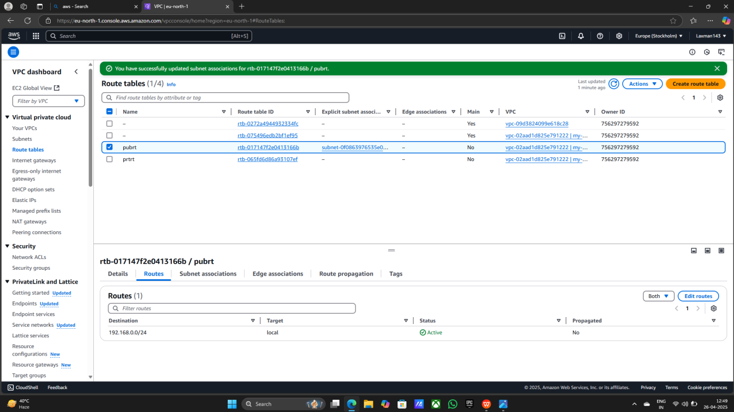

**> Click on Edit Route**

**> Select 0.0.0.0/0**

**> Select Internet Gateway**

**> Select igw-0971543de78080d90**

**> Save changes**

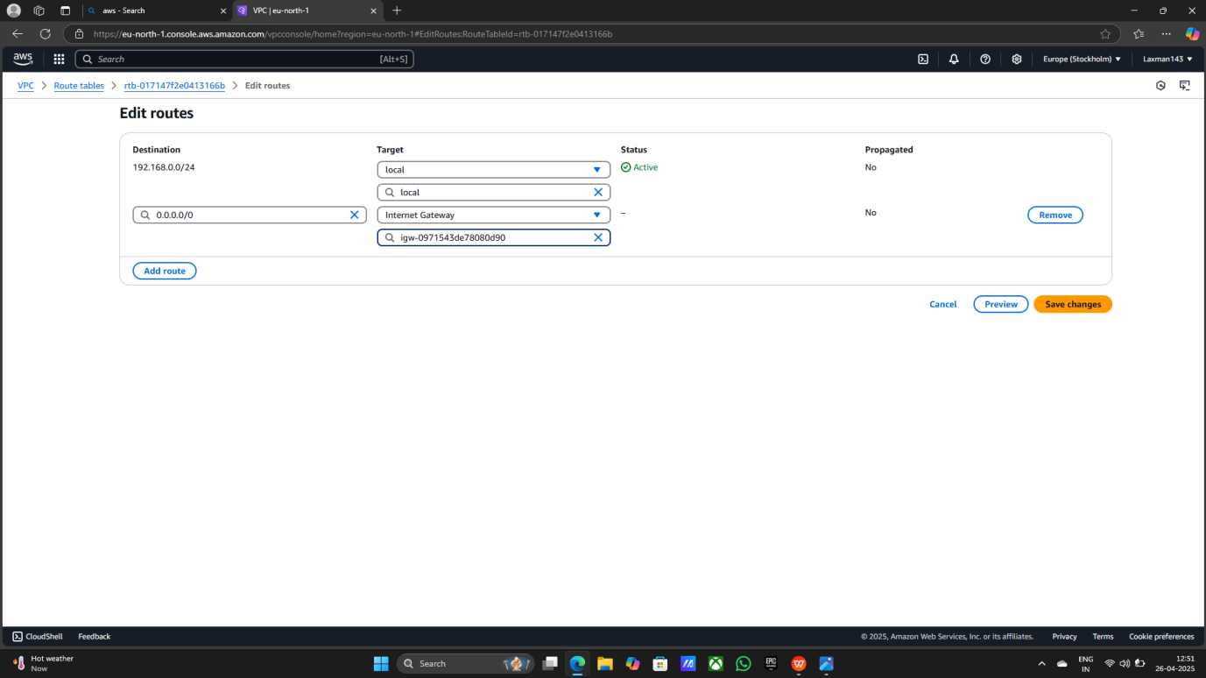

**Step5: 1) Fourth Internet gateways**

**> Create Internet Gateway**

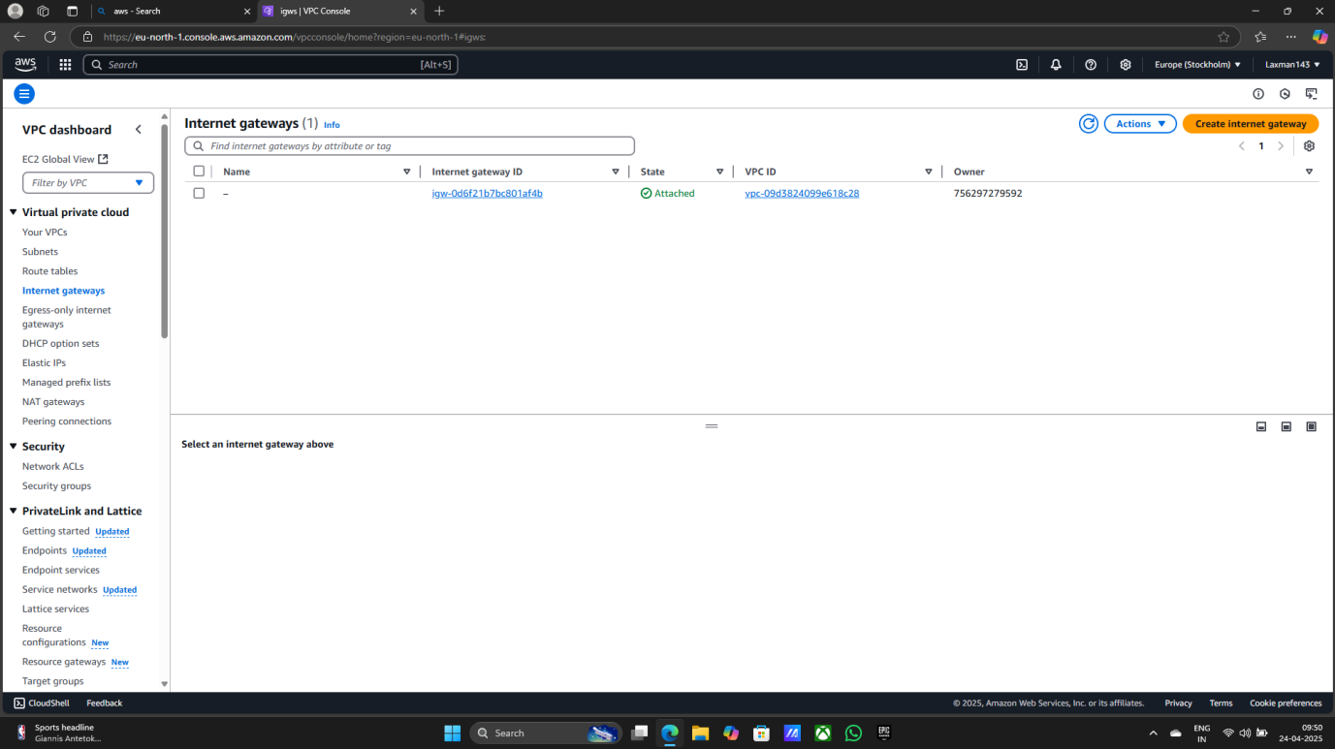

1. **Creating Internet gateways**

**> Give the Internet gateway name (ig1)**

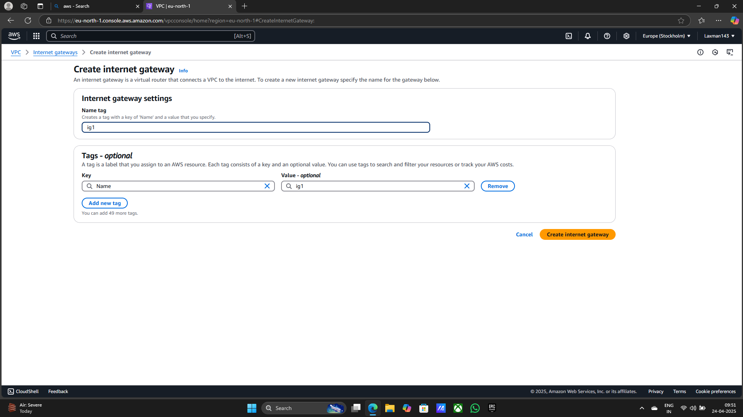

**> Continue Create Internet gateway**

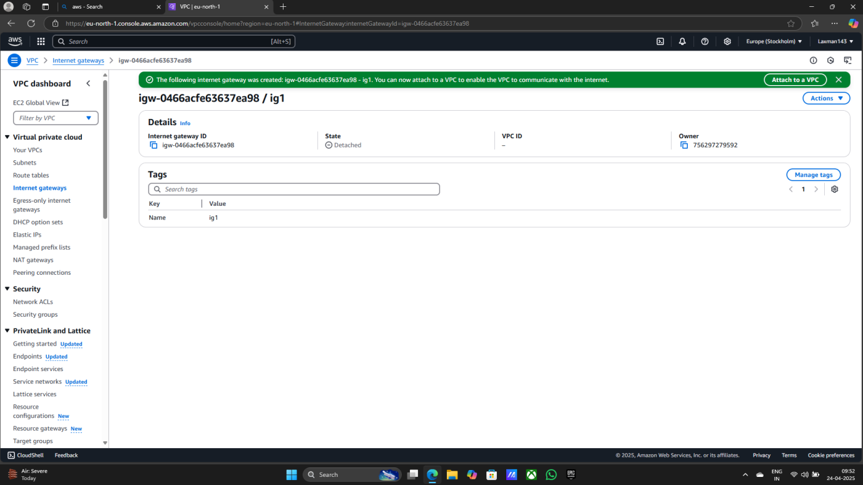

**> Intenet gateway Attach to VPC**

**> Select interet gateway**

**> Click on Actions**

**> Select Attach to VPC**

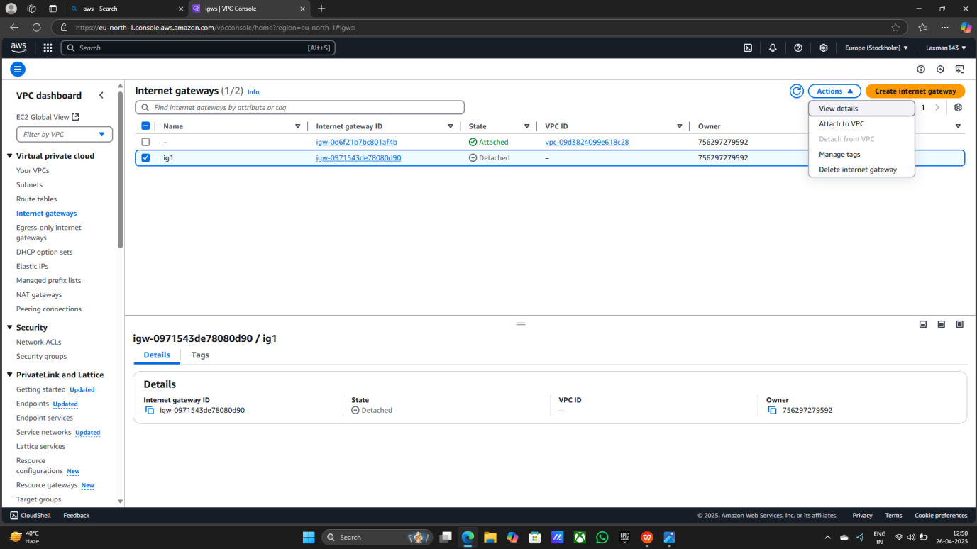

**> Select Attach to VPC**

**> Click on Attach Internet gateway**

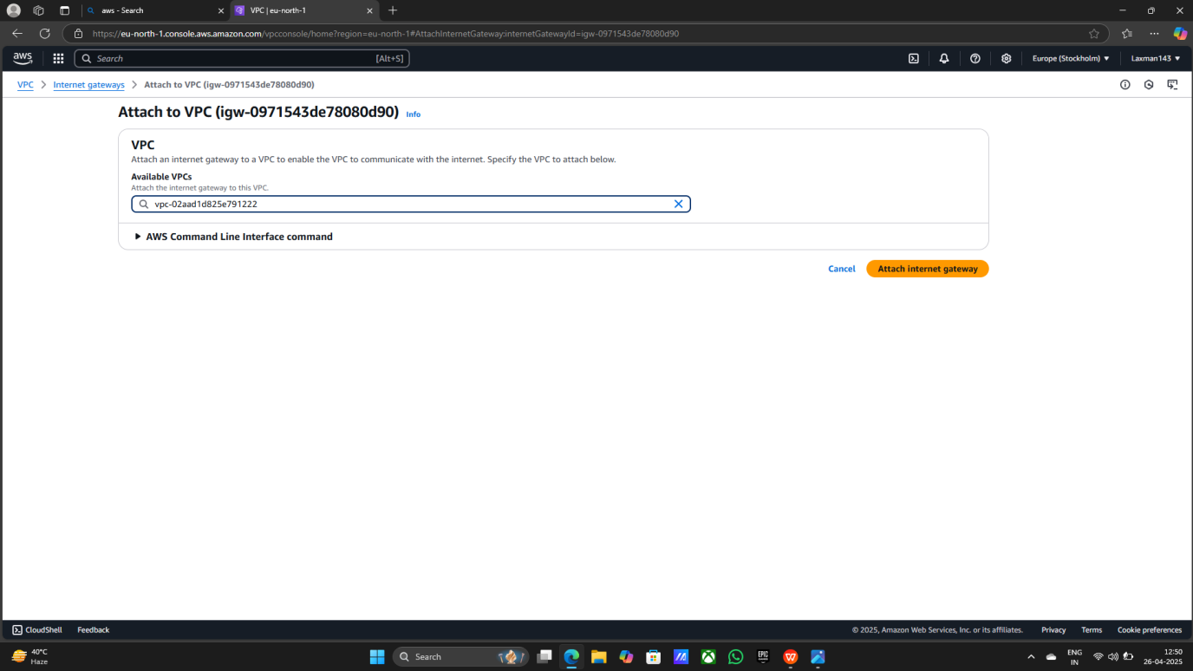

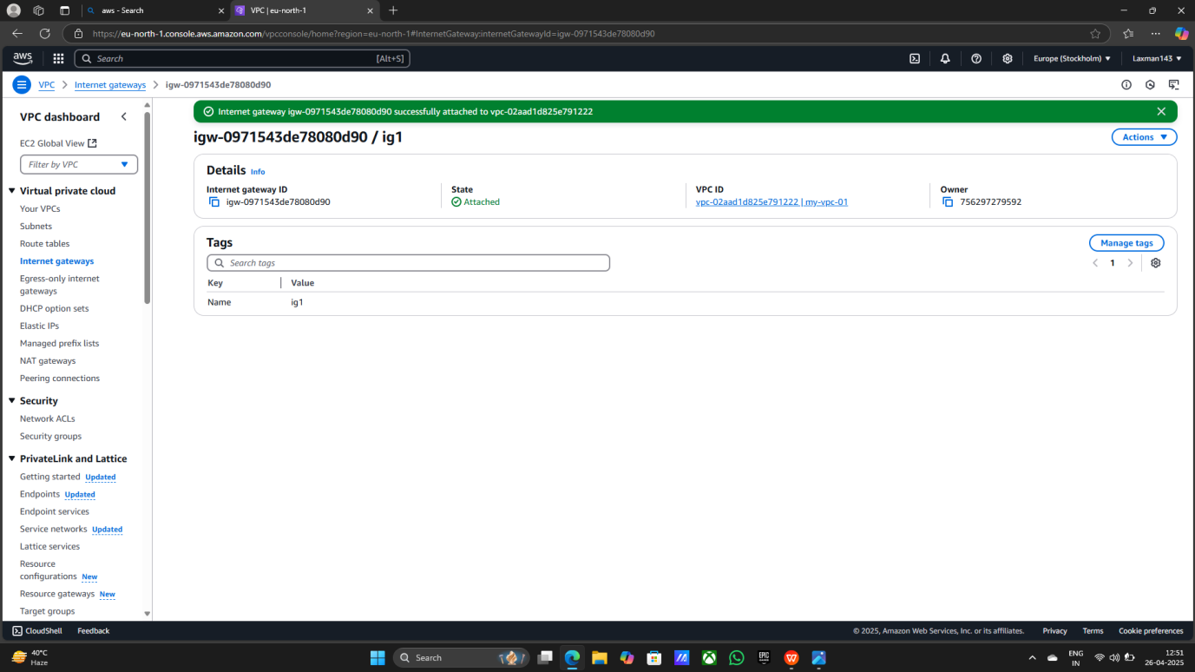

**> After Creating All this things in VPCs Look like that**

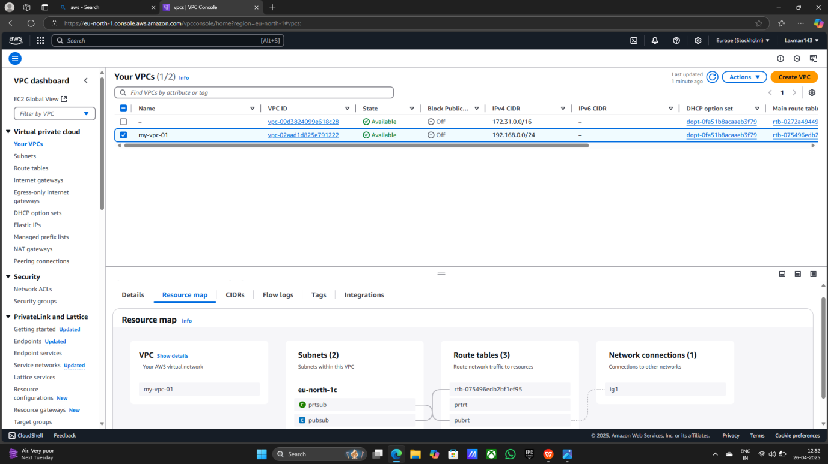

**Step6: 1) Search EC2**

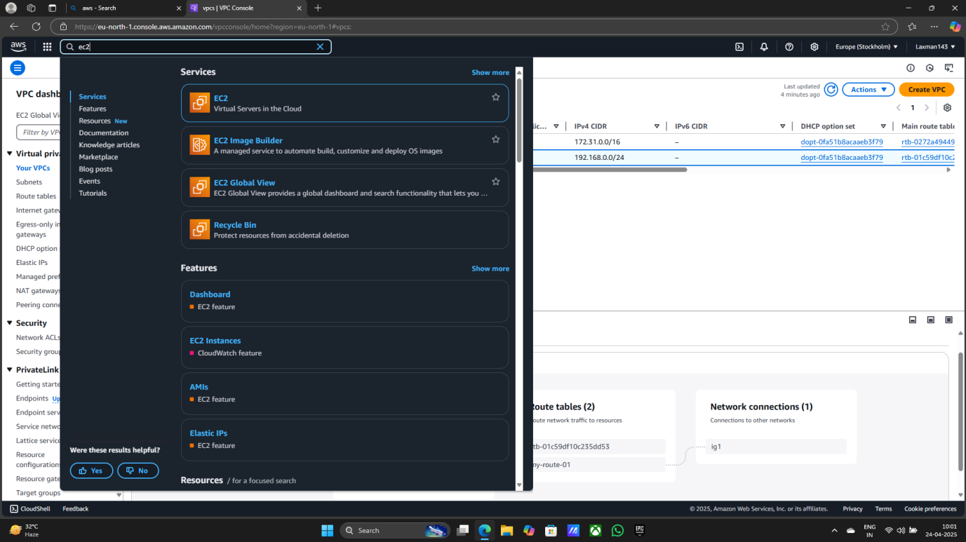

1. **Creating EC2 Instance**

**> Launch Instances**

**> Give the name (Laxman)**

**> Select OS (Ubuntu)**

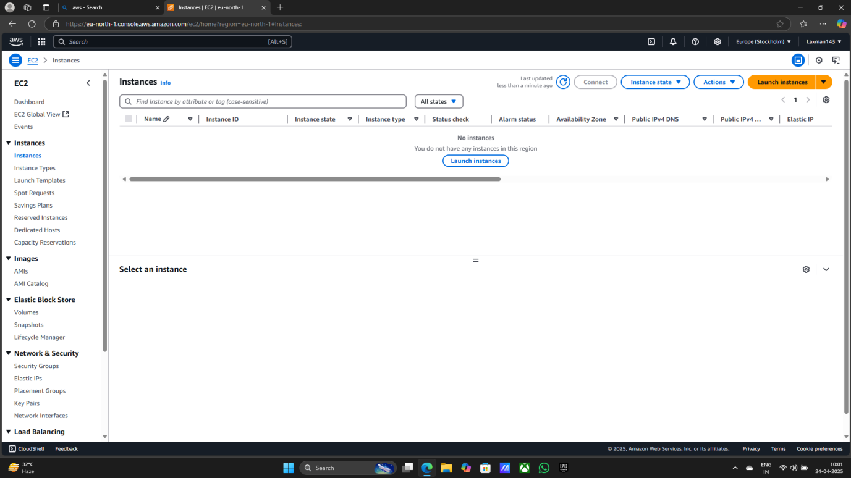

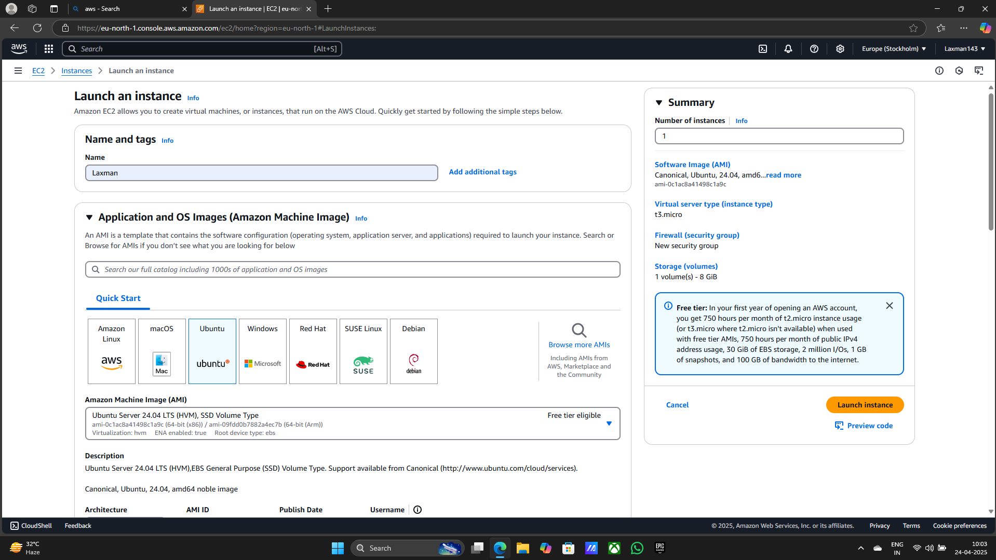

**> Select Instance Type (t3.micro)**

**> Create Key pair**

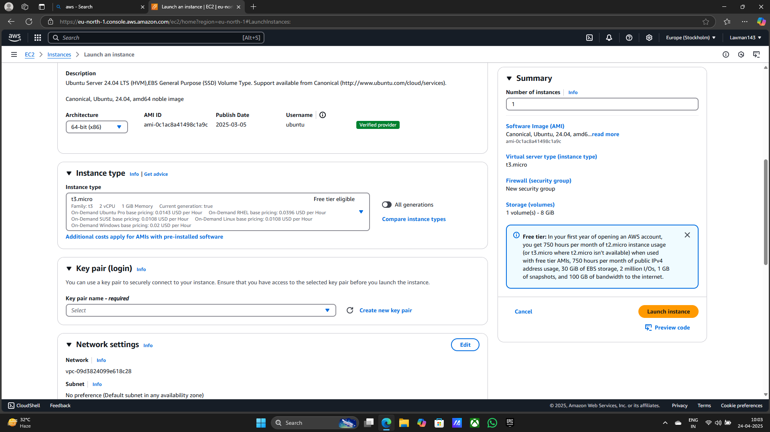

**> Key Pair Name**

**> Select RSA**

**> Select .pem**

**> Create Key Pair**

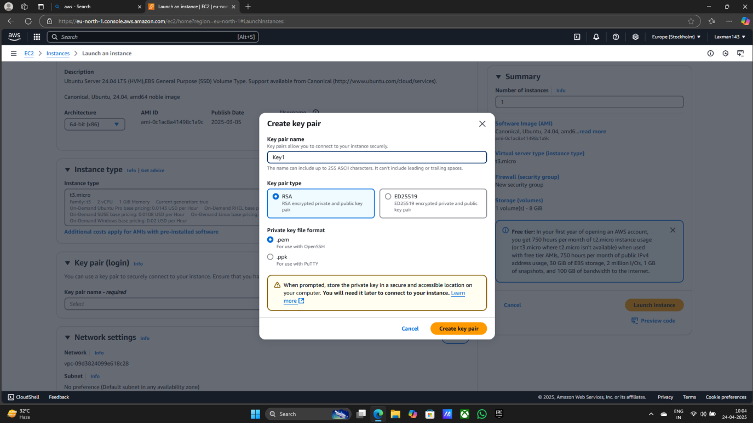

**> Select created VPC**

**> Select Public Subnet**

**> Auto assign public ip Enable**

**> Create Security Group**

**> Edit Rules**

**> Type (All traffic)**

**> Security Type (Anywhere)**

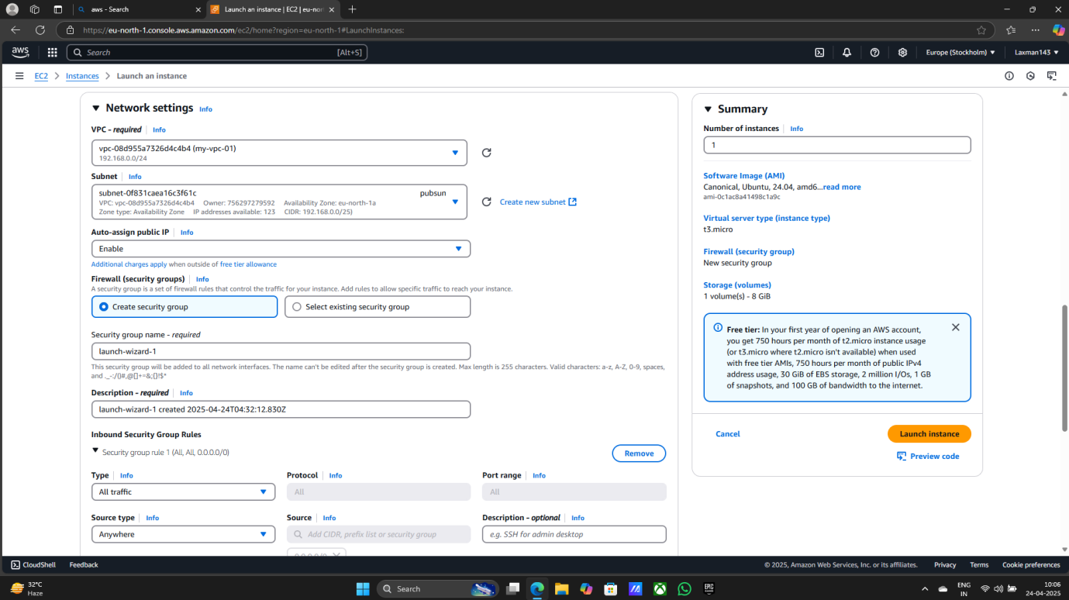

**> Launch Instance**

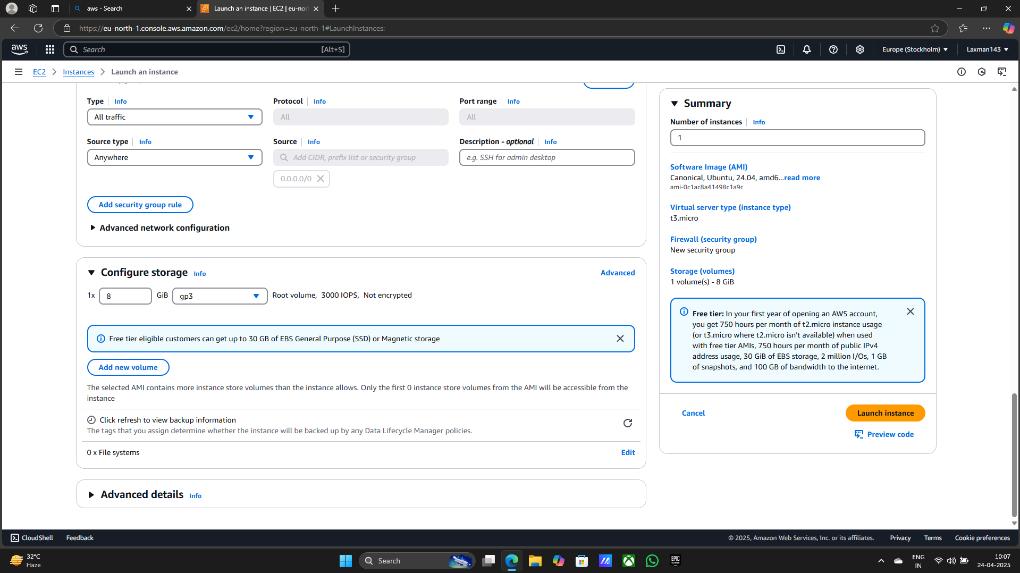

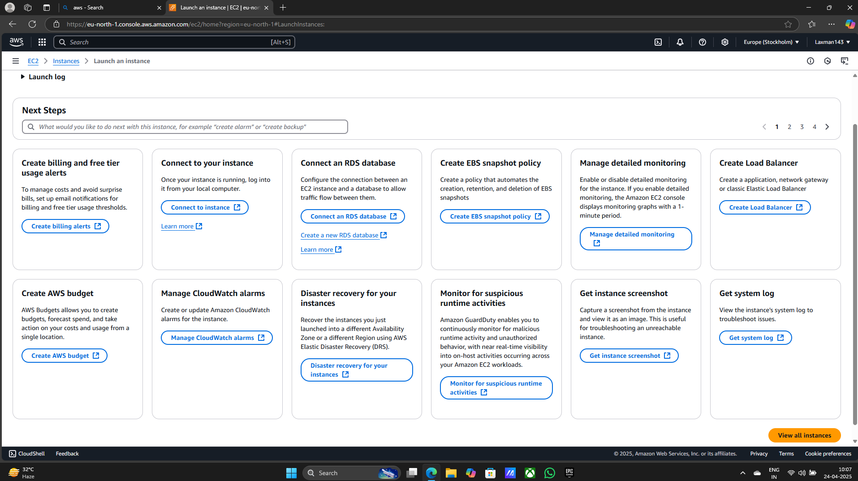

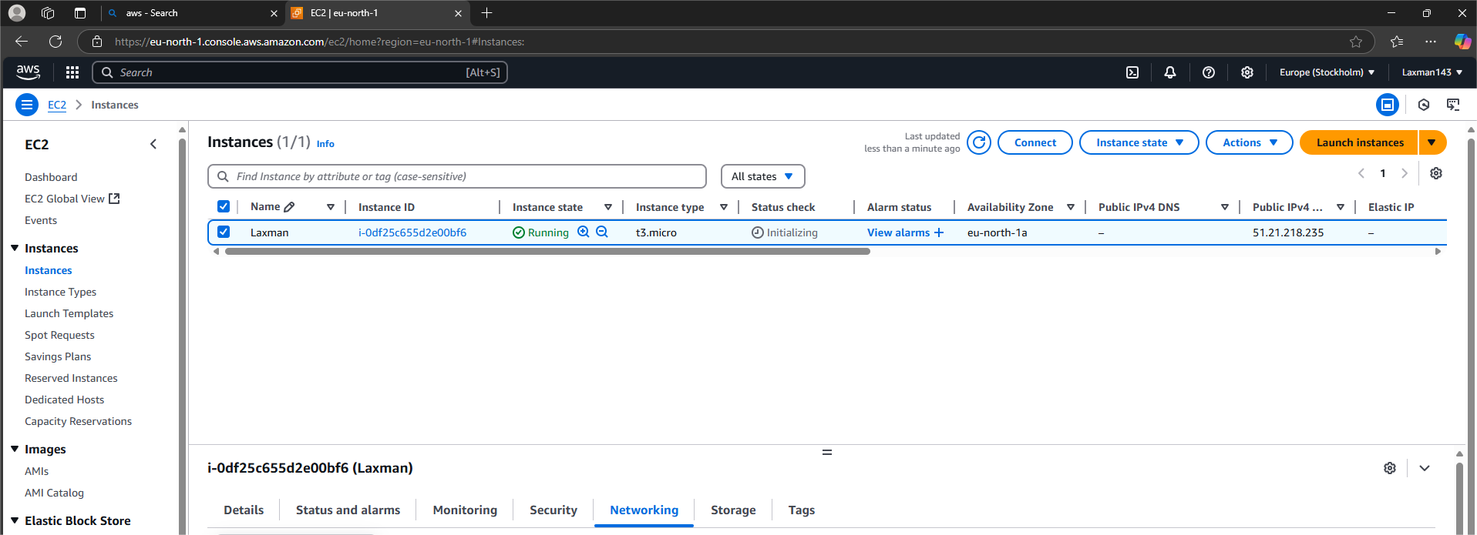

**Step7: 1) After creating EC2 Instance**

**2) Copy the public Ipv4 address**

**3) Open the Mobaxterm**

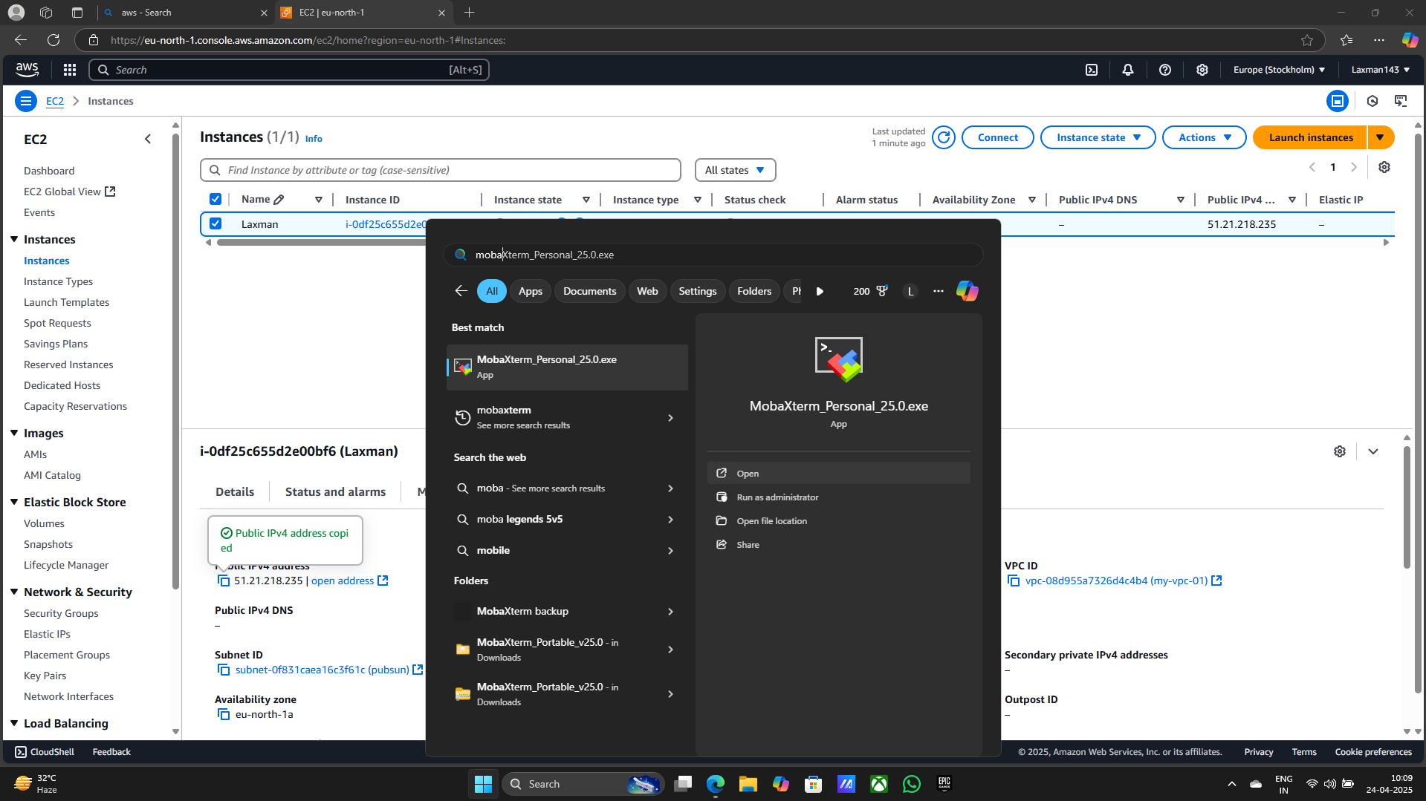

**> click on Session**

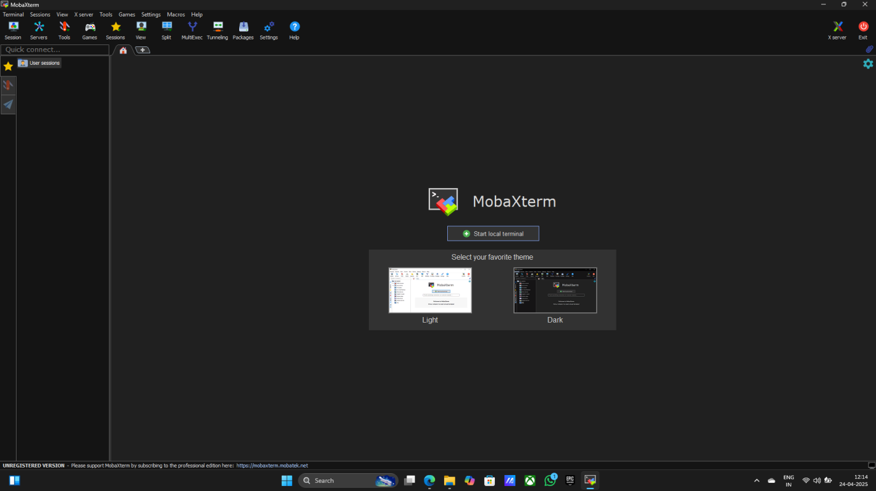

**> Click on SSH**

**> Paste the public ipv4 address in Remote host**

**> Click On Specify username (Ubuntu)**

**> Click on Advanced SSH settings**

**> Use private key from downloads**

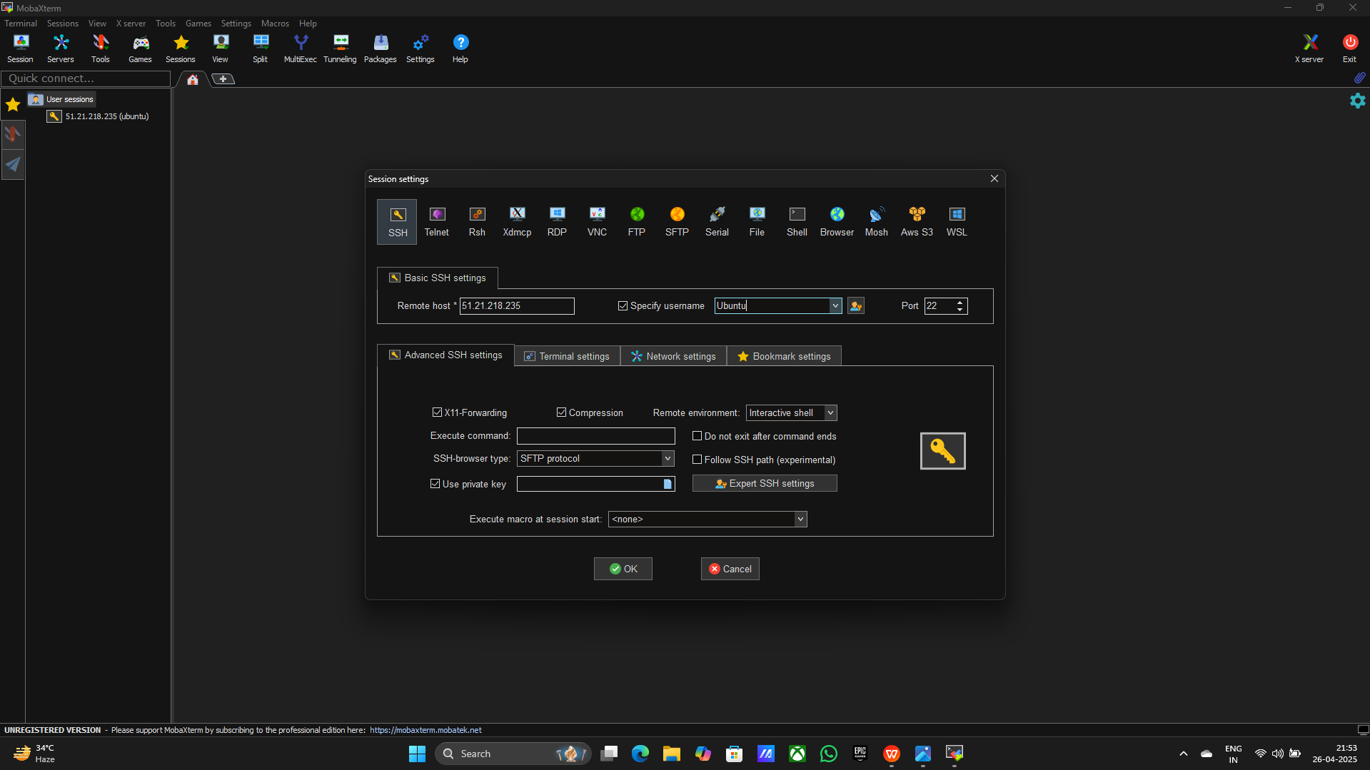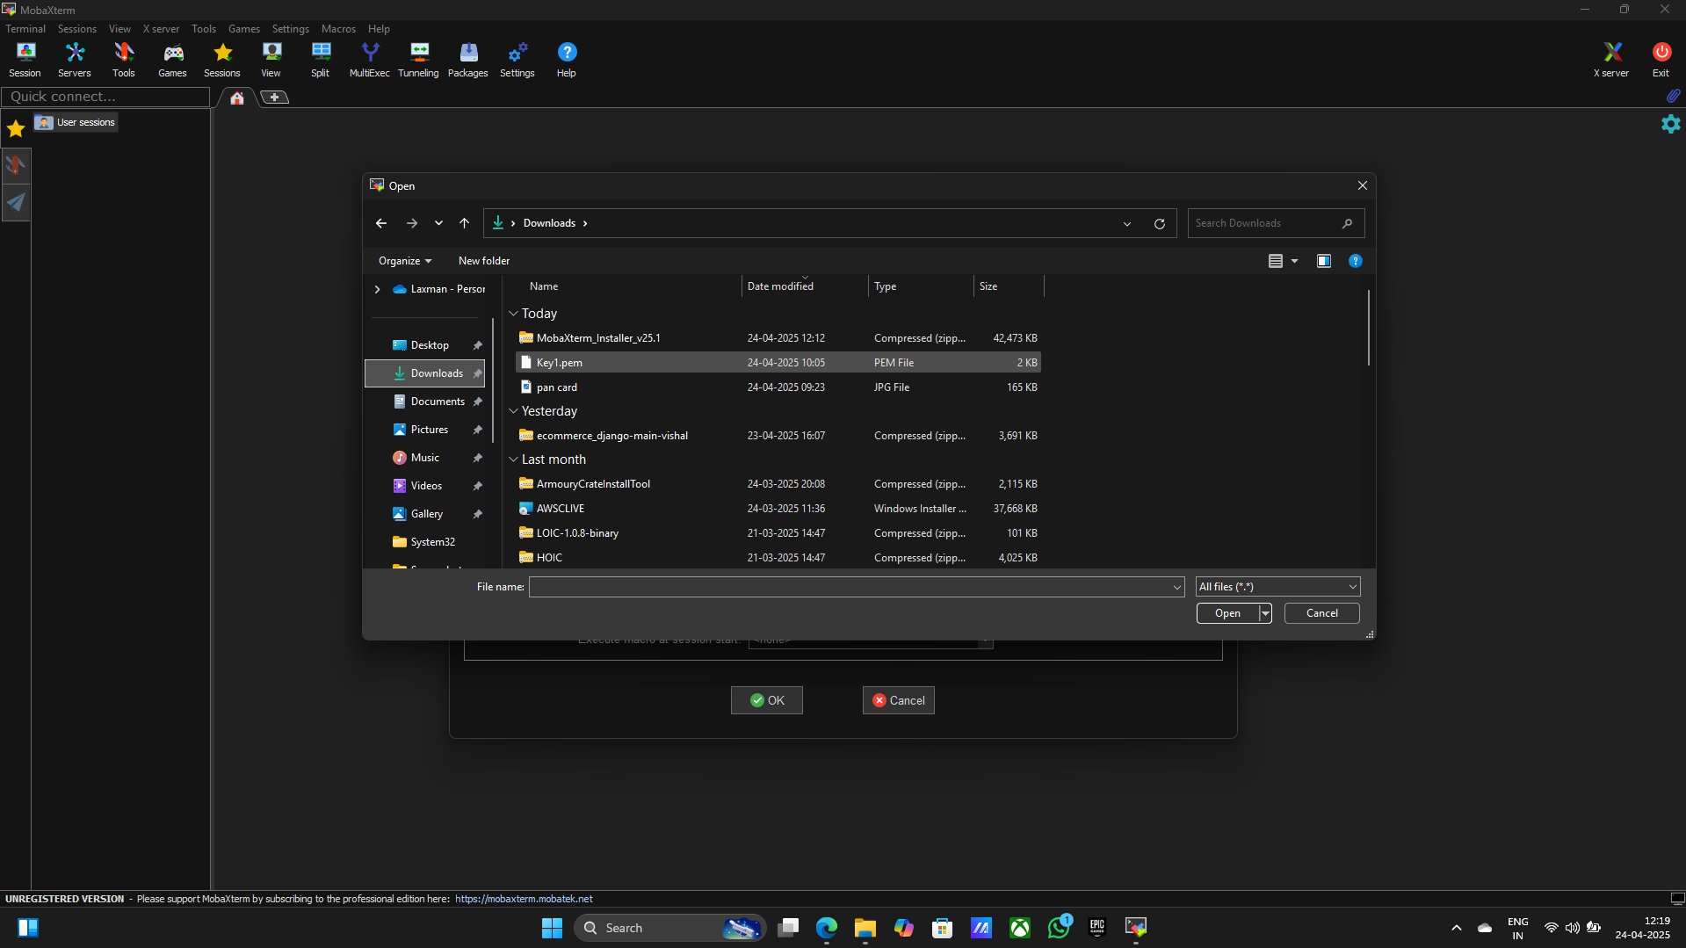

**> Click on ok to start session**

**> Accept for communication**

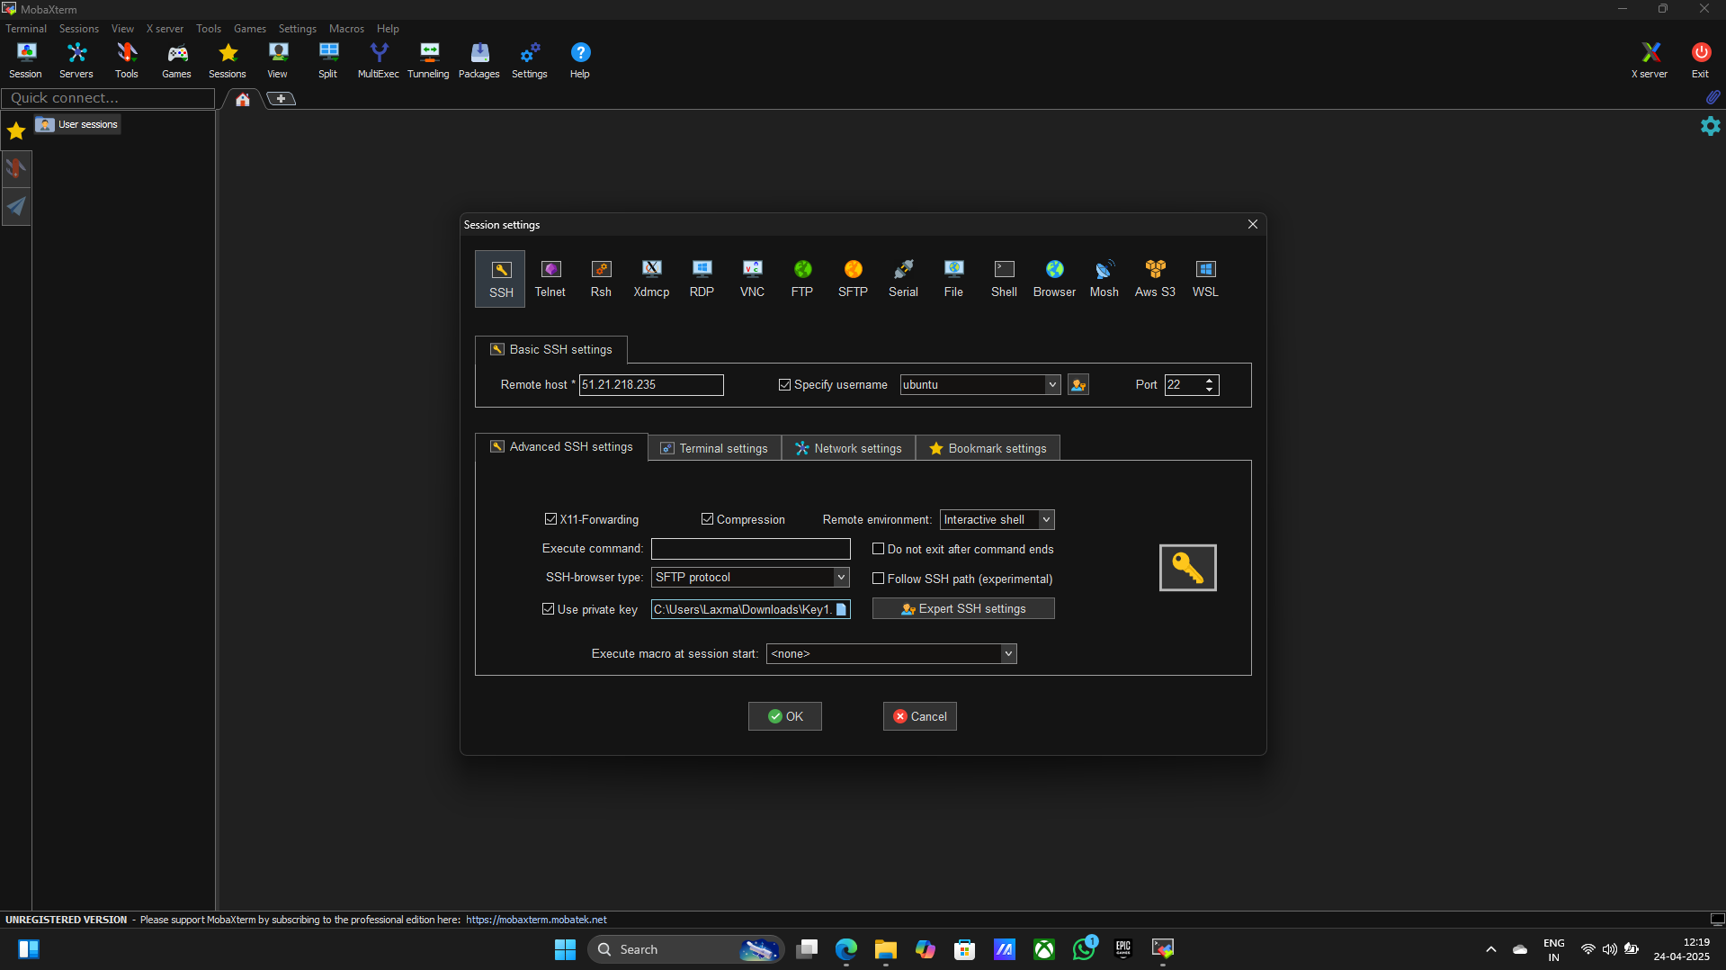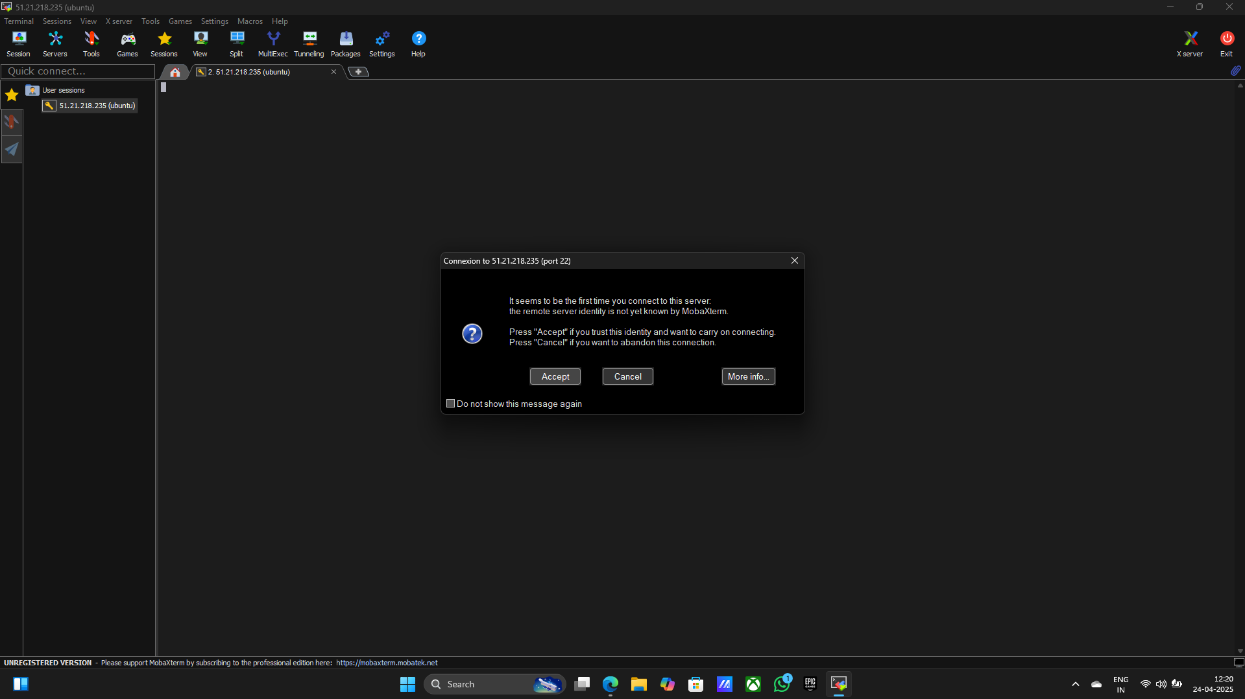

**> Session will be Start**

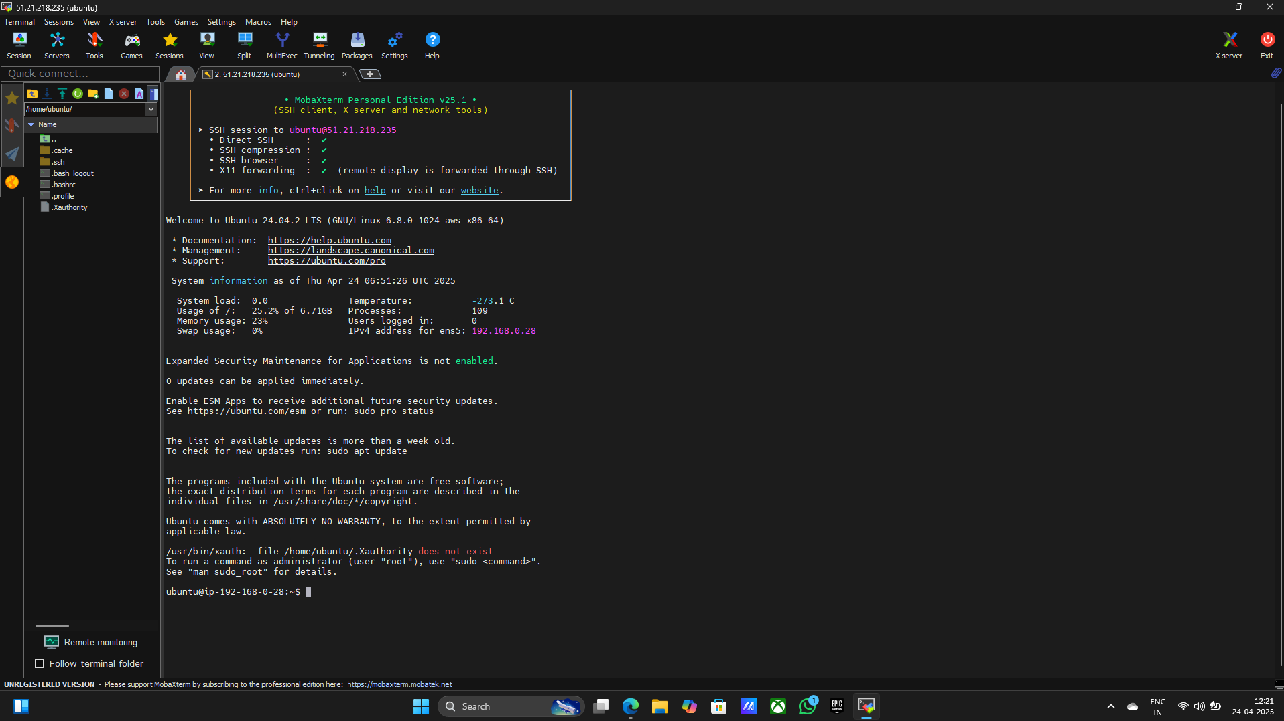

**Step8: Start configuration**

1. **sudo -i**
2. **apt update -y**

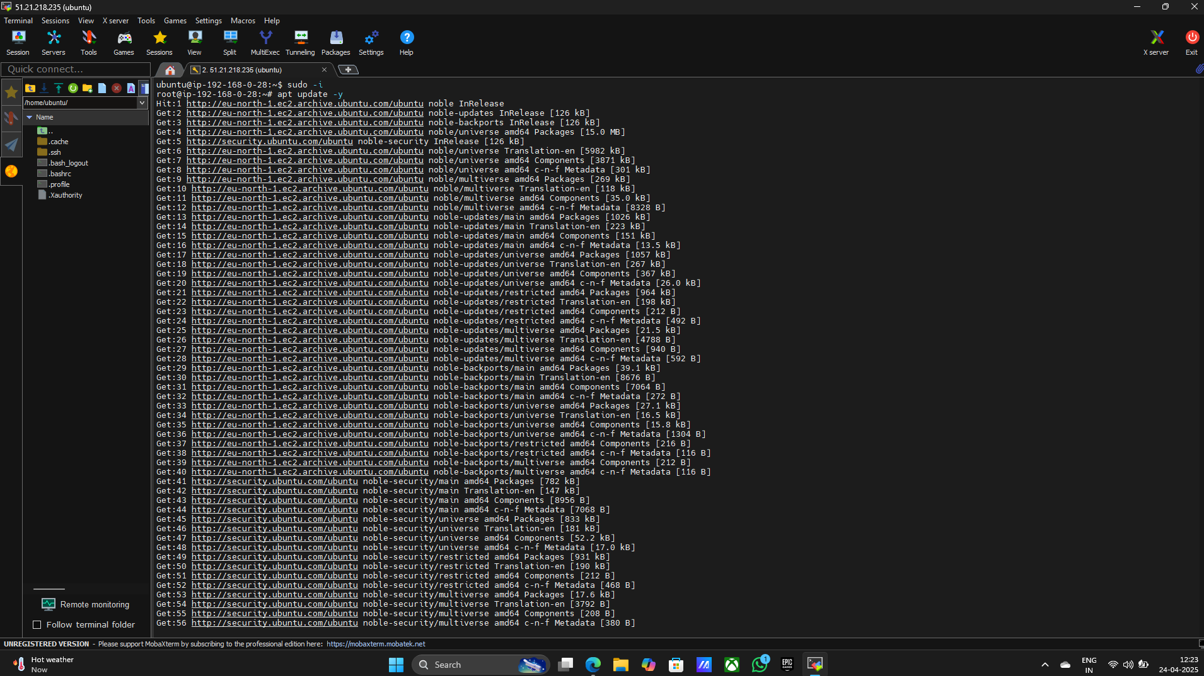

1. **Upload the code file from downloads**

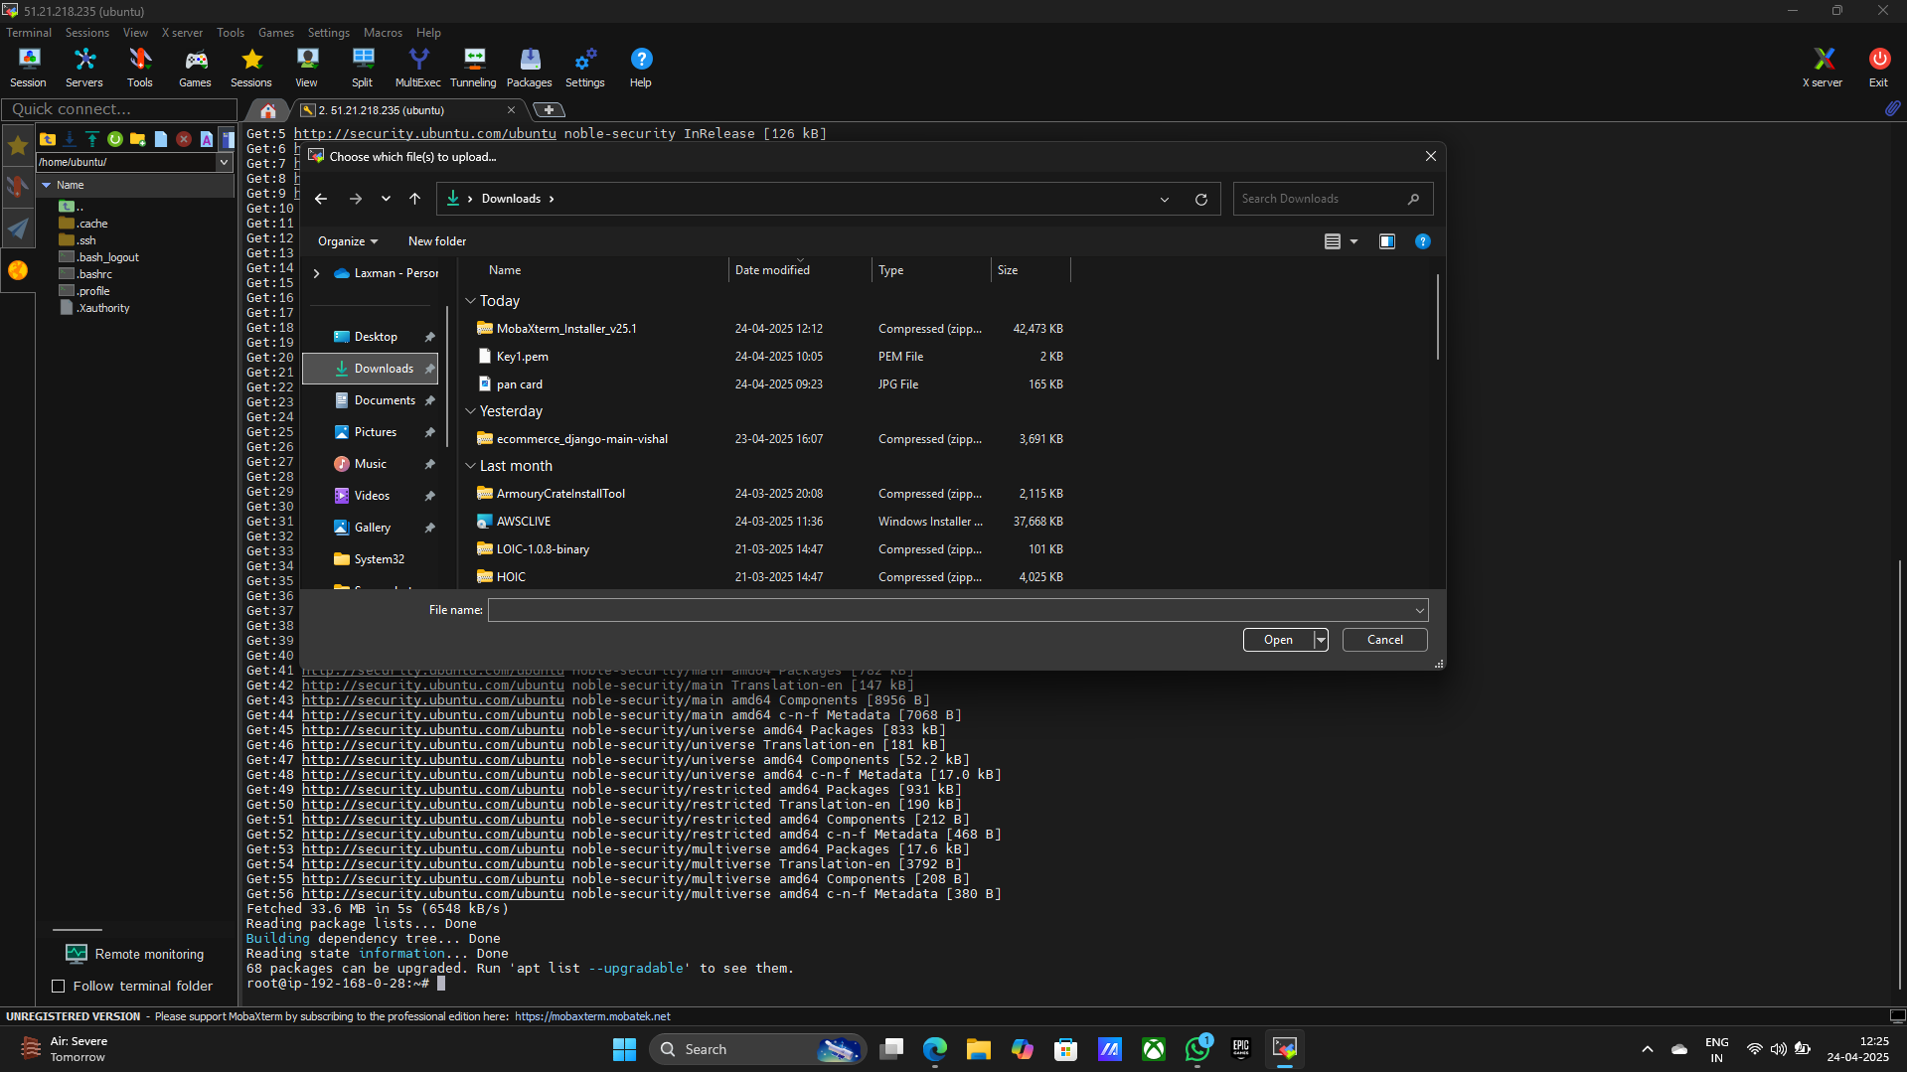

1. **cd /home/ubuntu**
2. **apt in9stall unzip -y**

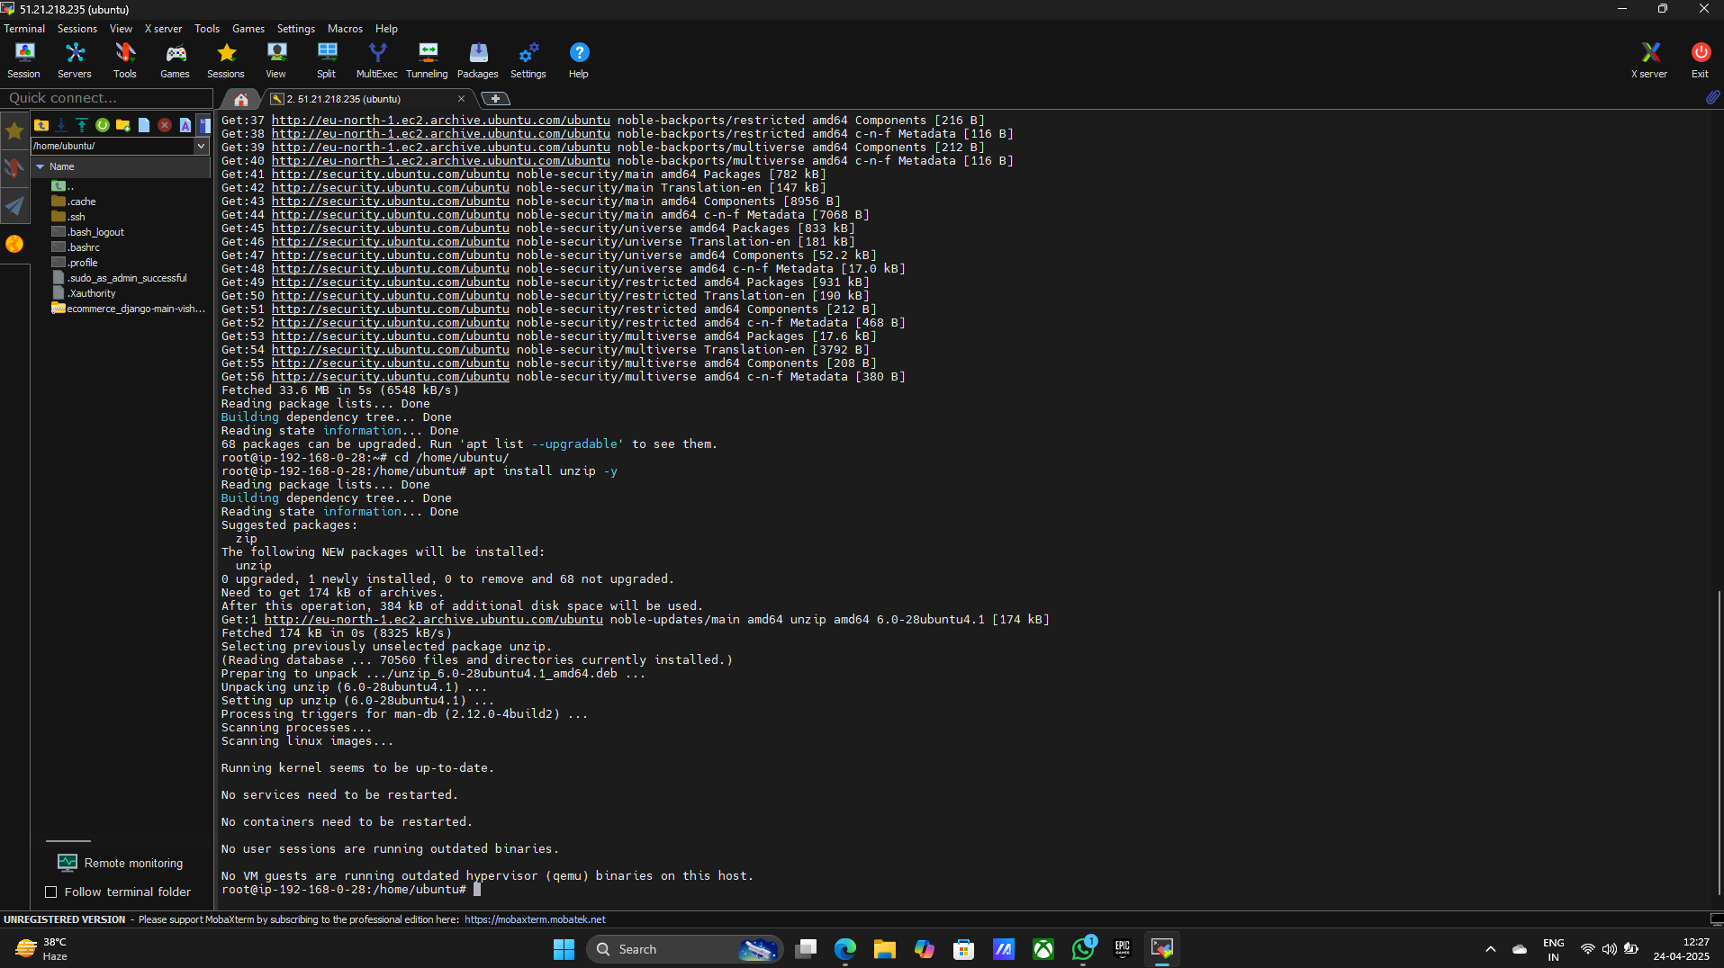

1. **ls**
2. **unzip ecommerce_django-main-vishal.zip**

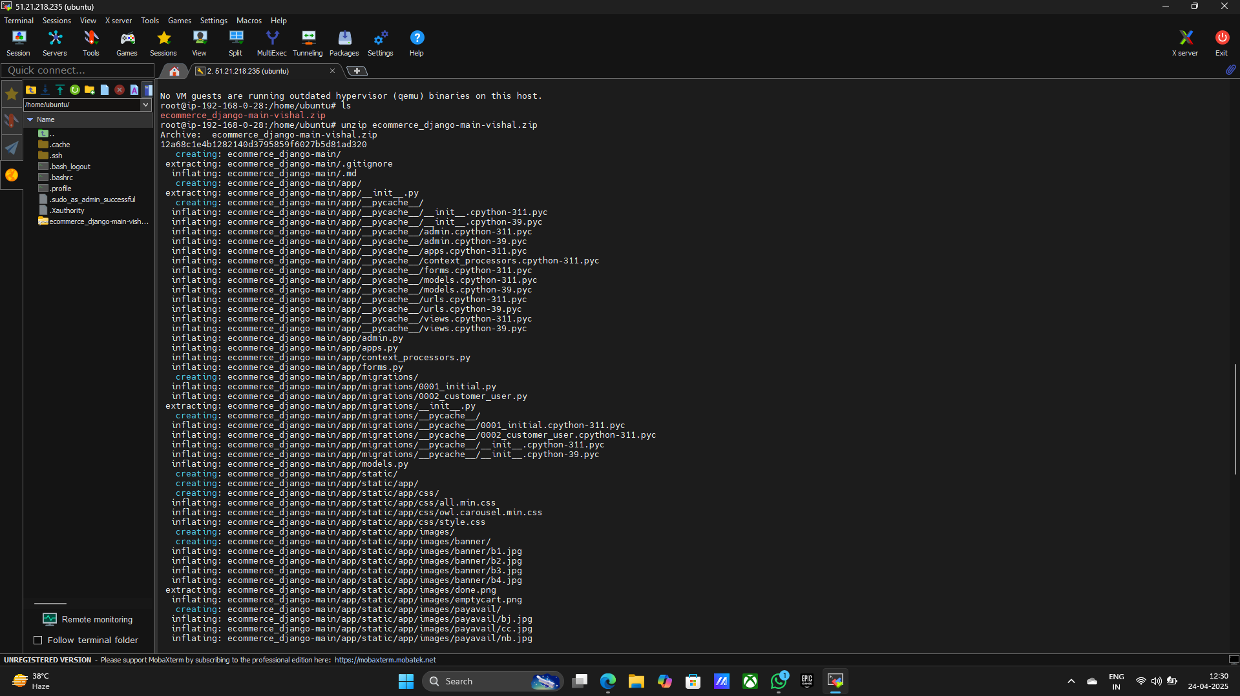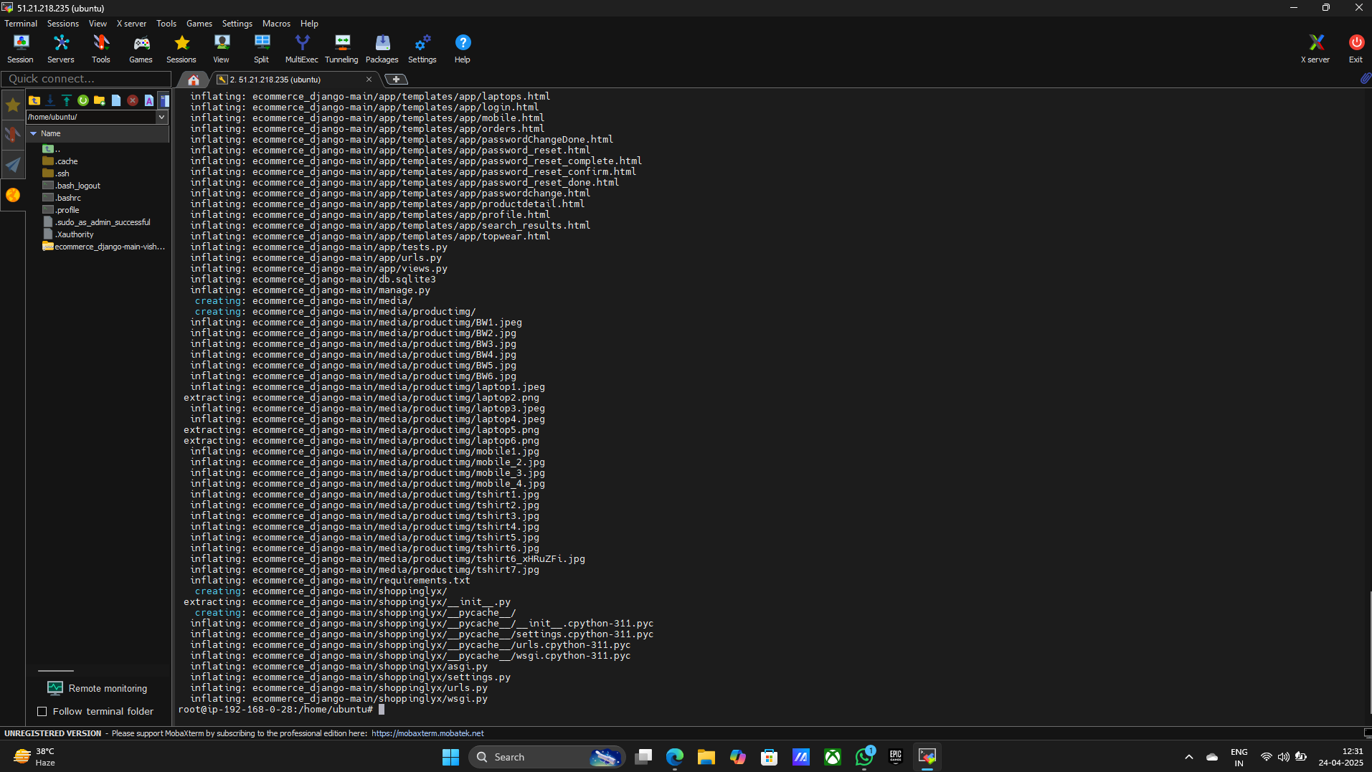

1. **cd ecommerce_django-main**
2. **apt install python3 . 12 -venv**
3. **Y**

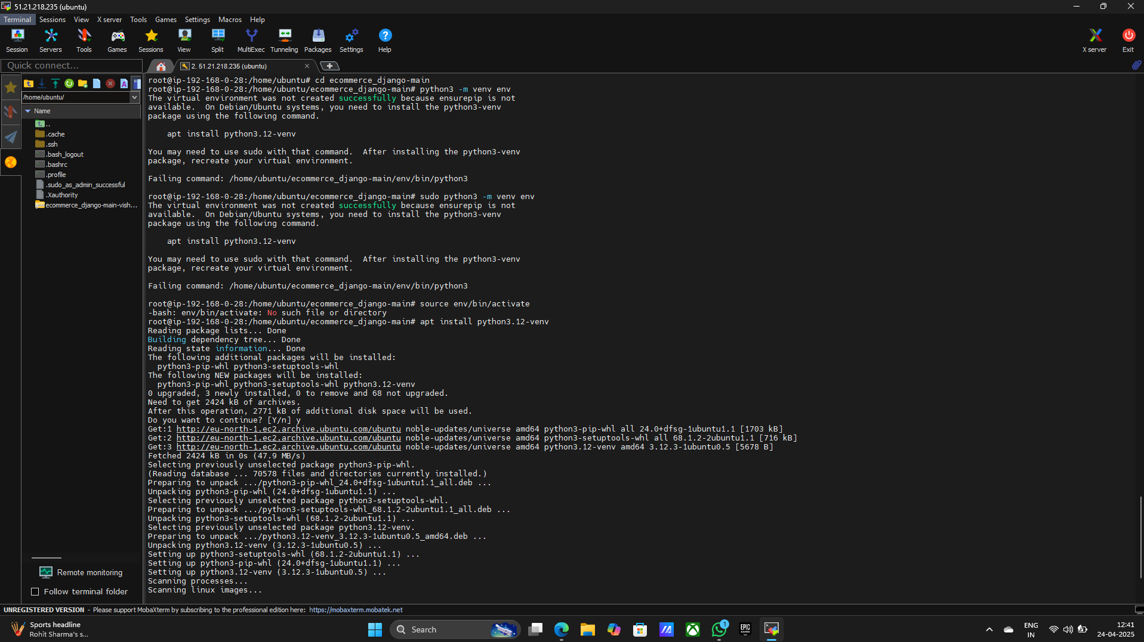

1. **sudo python3 -m venv env**
2. **Pip install -r requirements.txt**
3. **apt install Python3 – pip**
4. **Y**

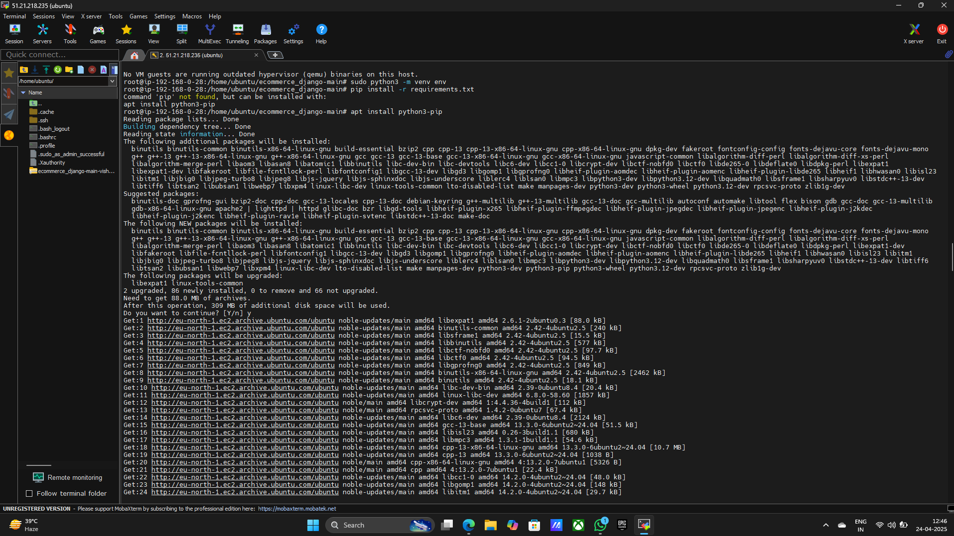

1. **sudo apt update && sudo apt upgrade -y**

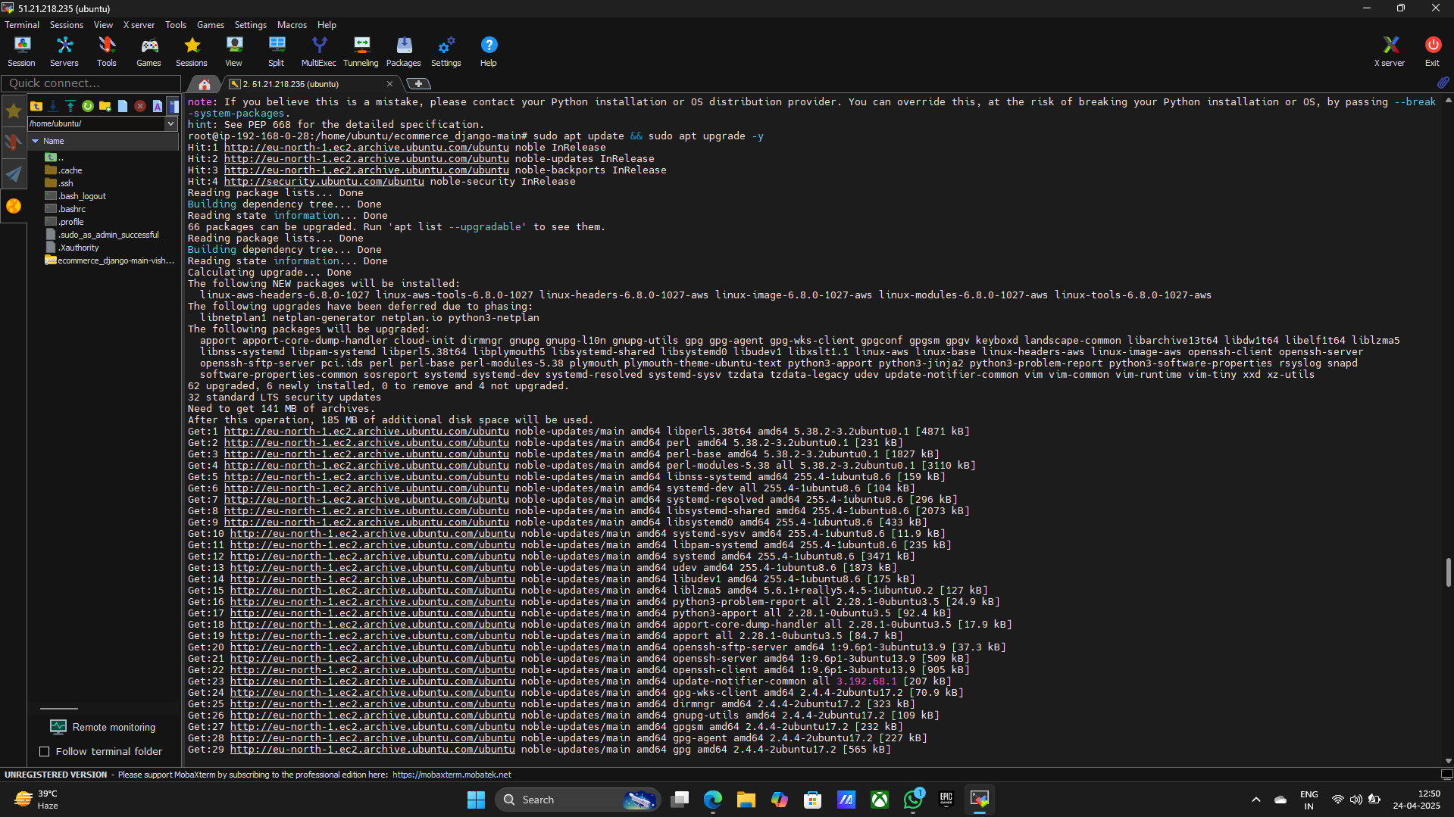

1. **sudo apt install python3-pip python3-dev python3-venv nginx git -y**

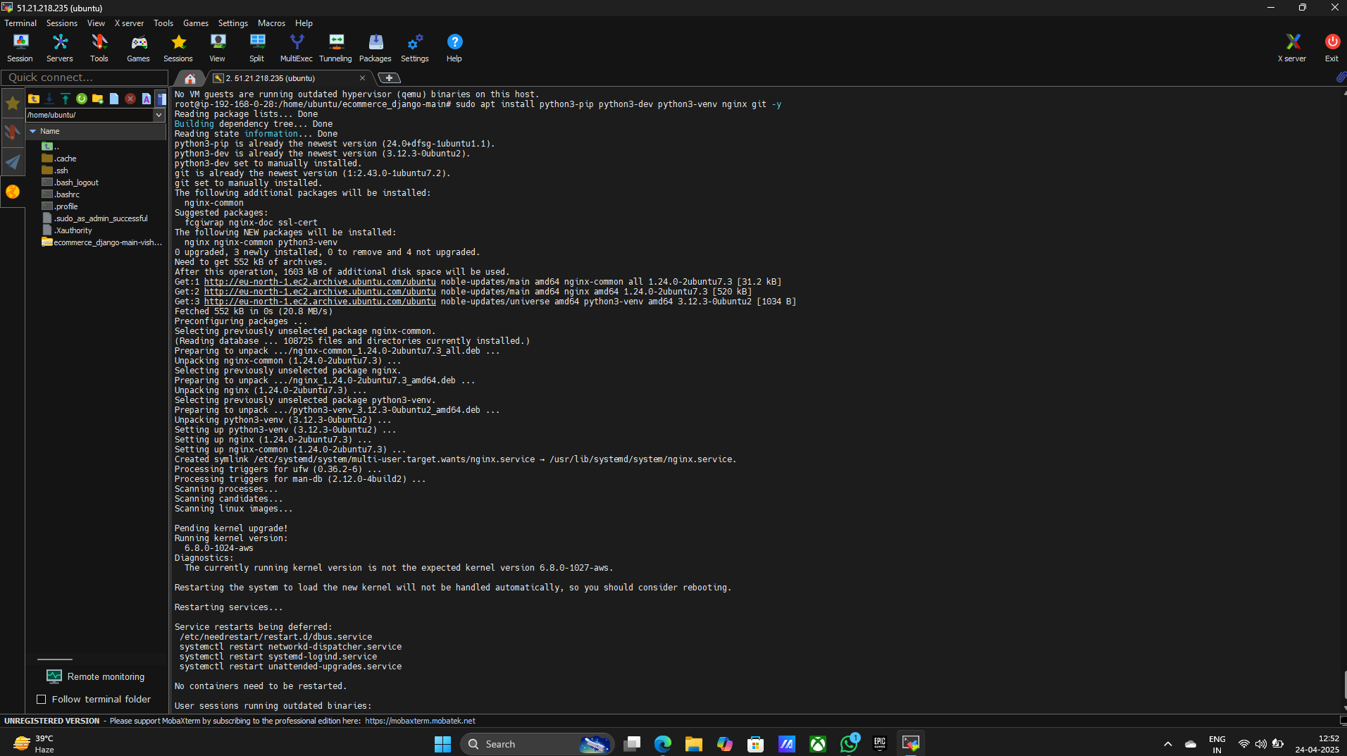

1. **python3 -m venv env**
2. **source env/bin/activate**
3. **cd shoppinglyx**
4. **vim settings.py**

**> Press i for changes and insert**

**> Insert ALLOWED_HOSTS = [‘51.21.218.235’]**

**> Insert #’shoppinglyx.settings.global_settings_env_var’, # Add this line**

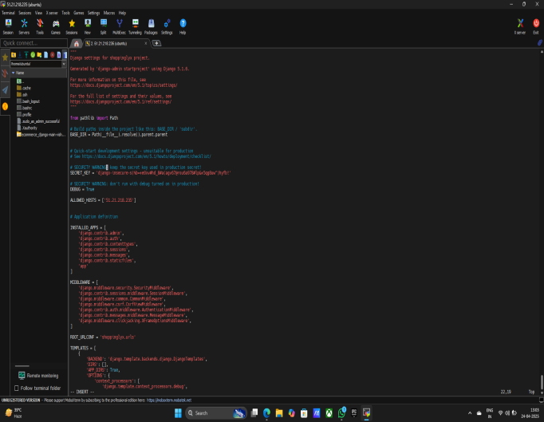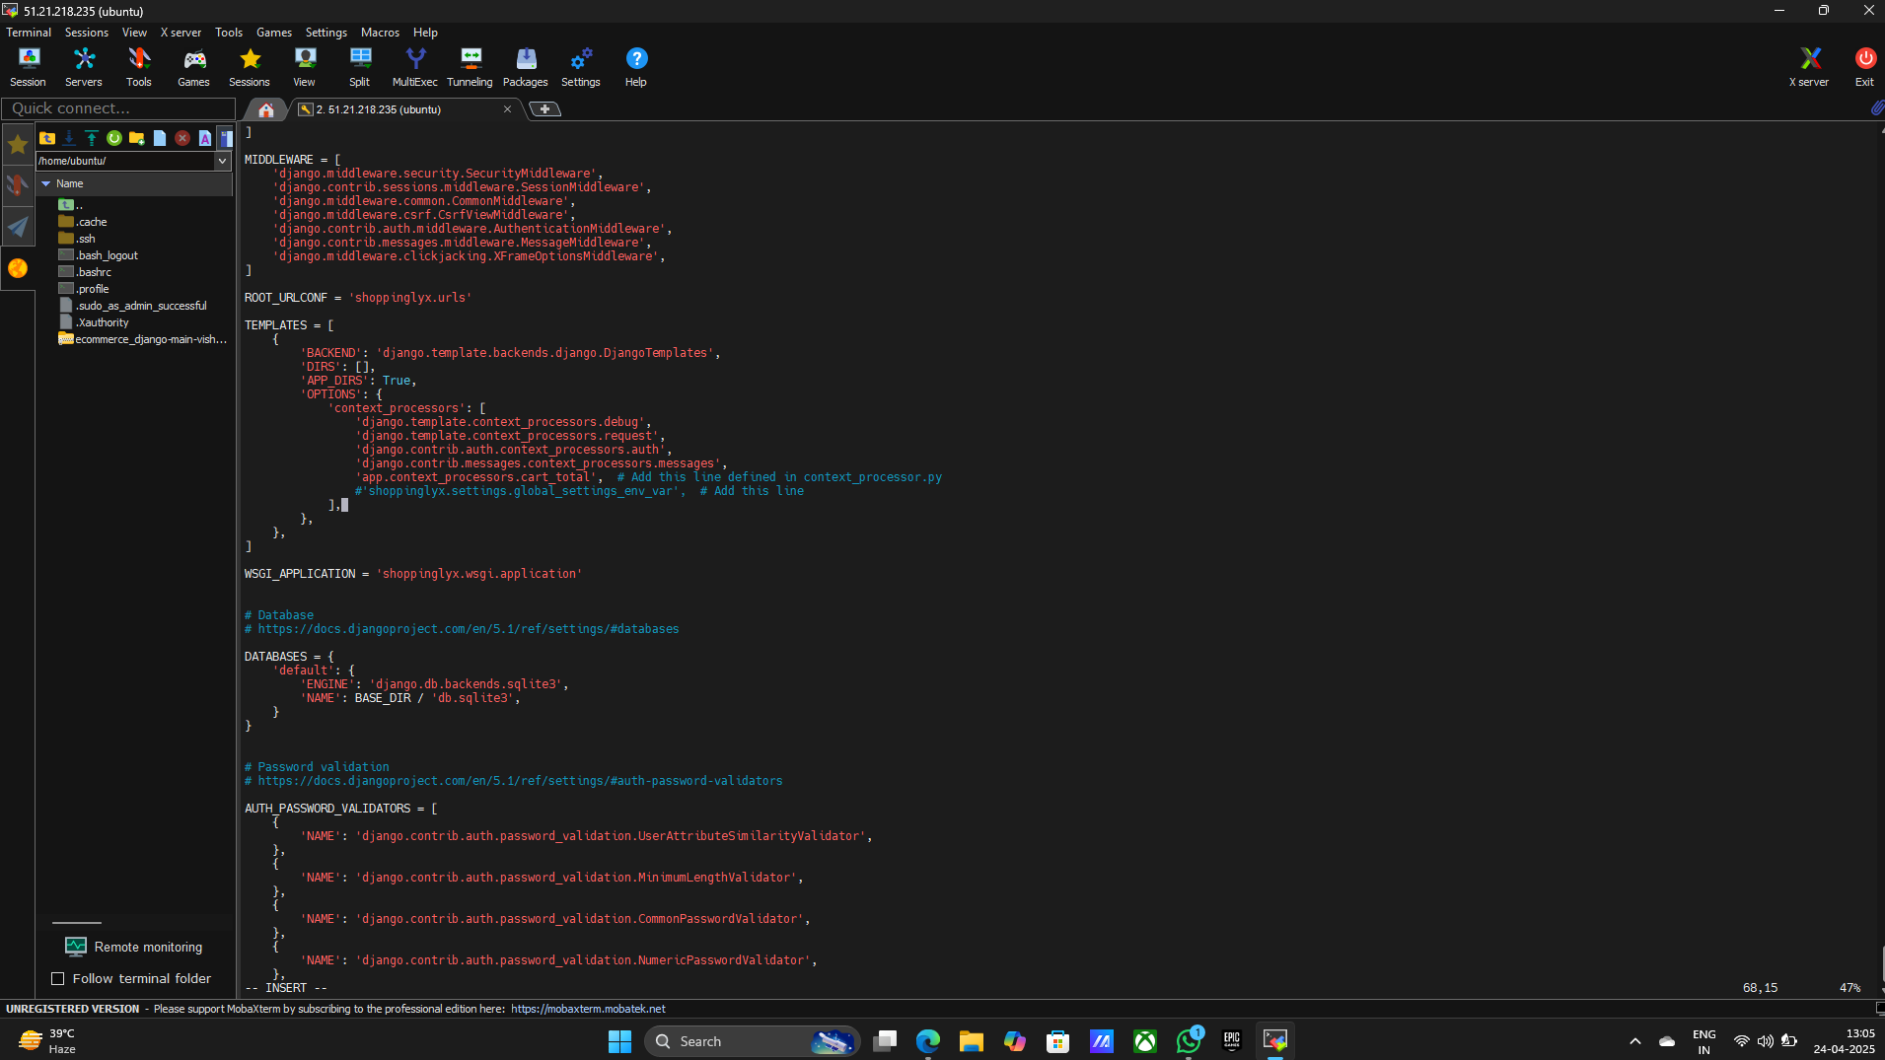

**> Delete Last 4 Lines in the code**

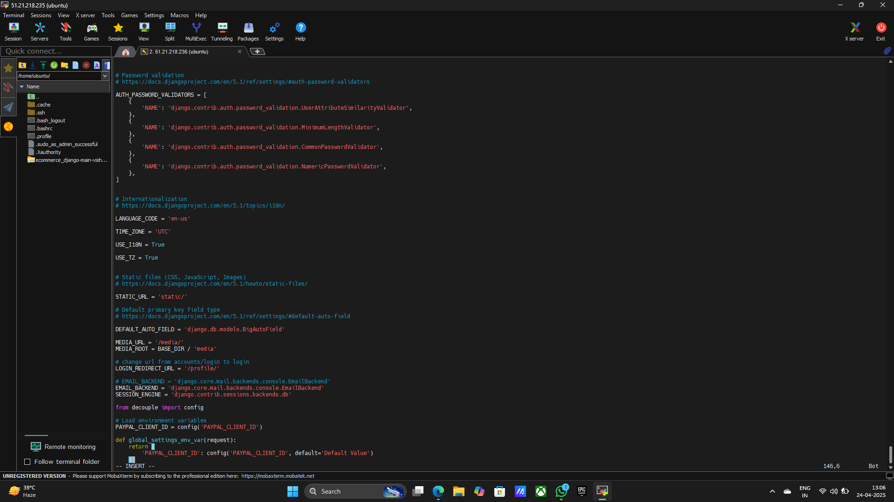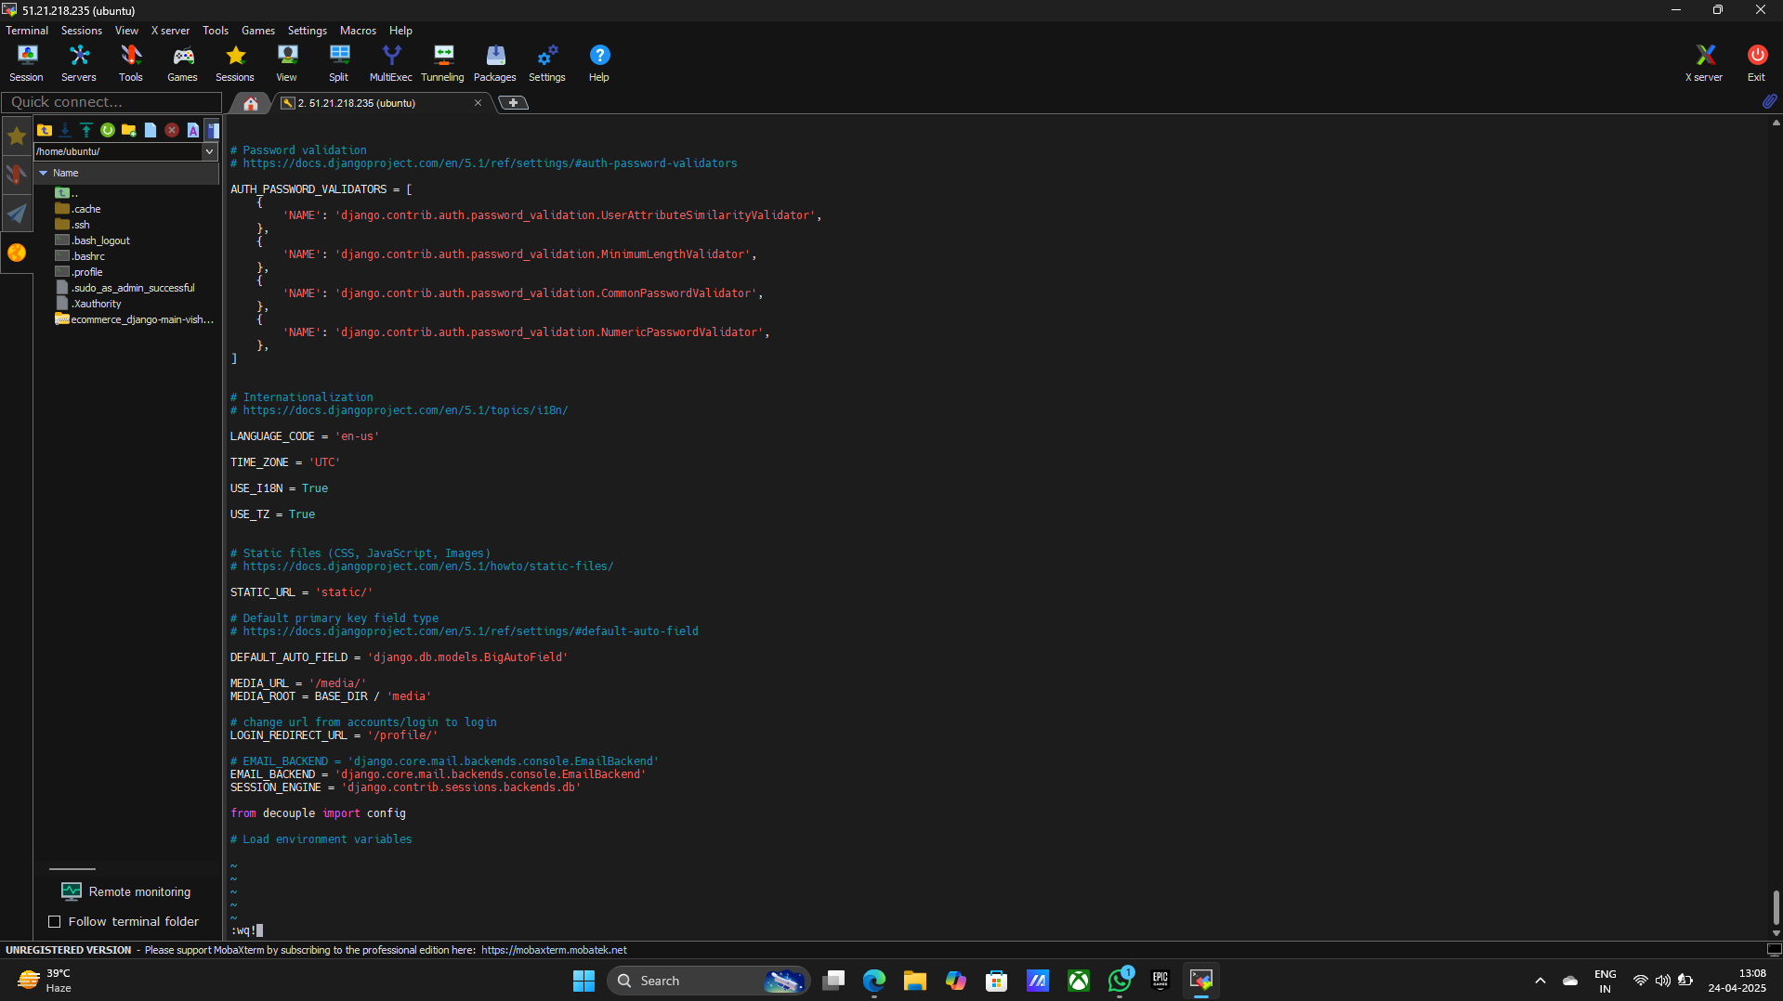

**> Exit the location Press ESC button**

**> Type :wq!**

**> Press Enter**

1. **cd ..**

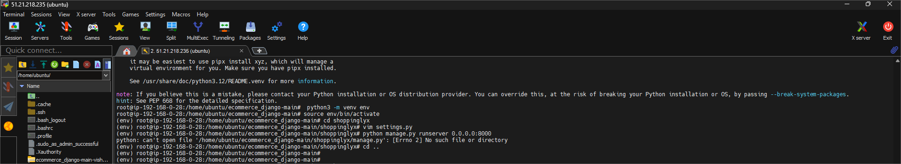

1. **pip install -r requirements.txt**
2. **python manage.py runserver 0.0.0.0:8000**

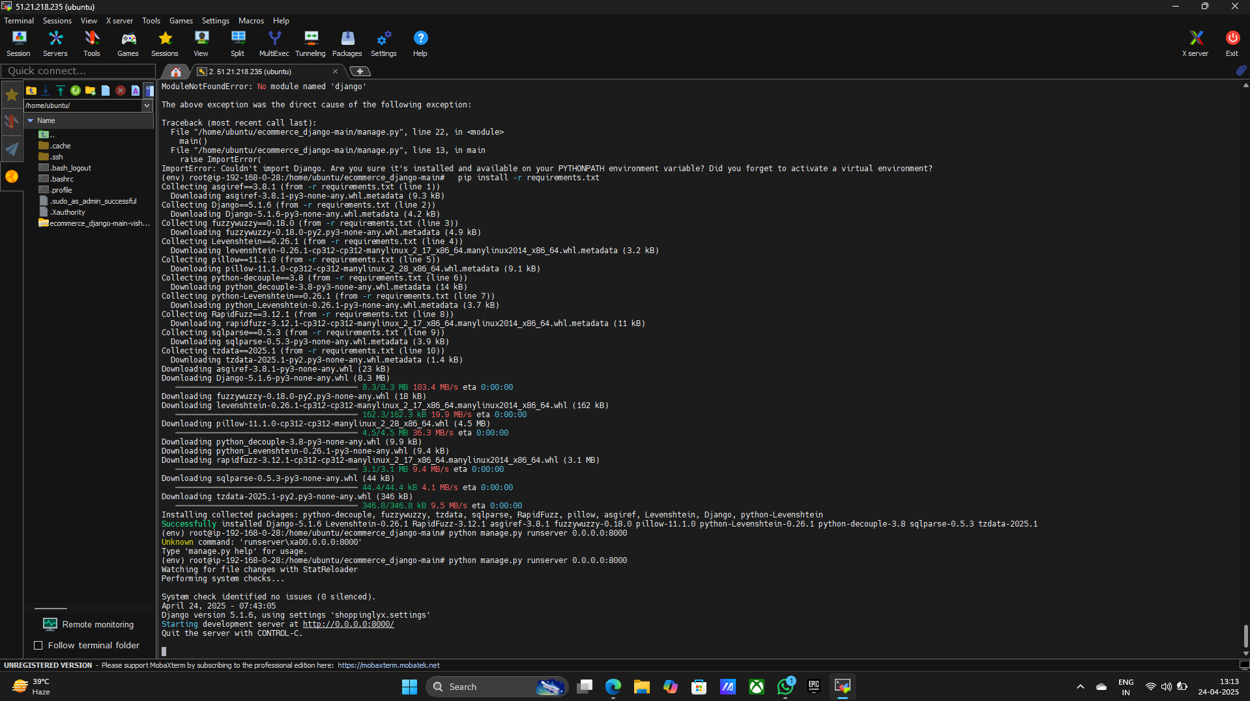

**Step10: open the wbsite**

1. **Open the browser**
2. **Paste public Ip 51.21.218.235:8000**

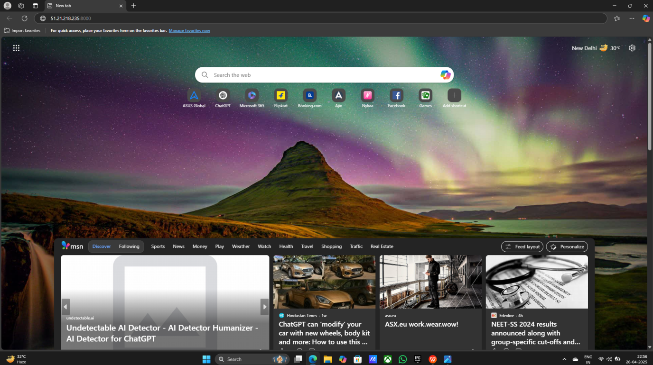

1. **See the website**



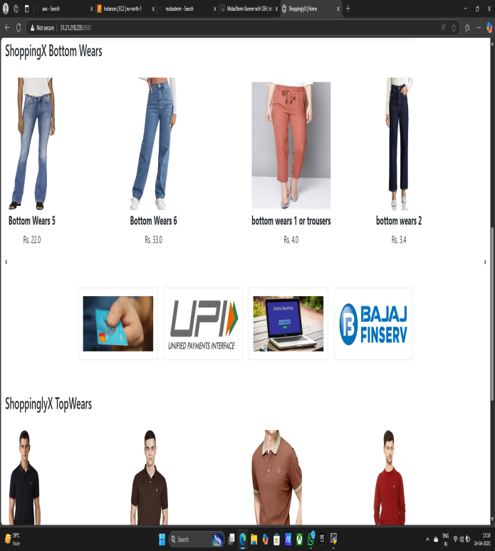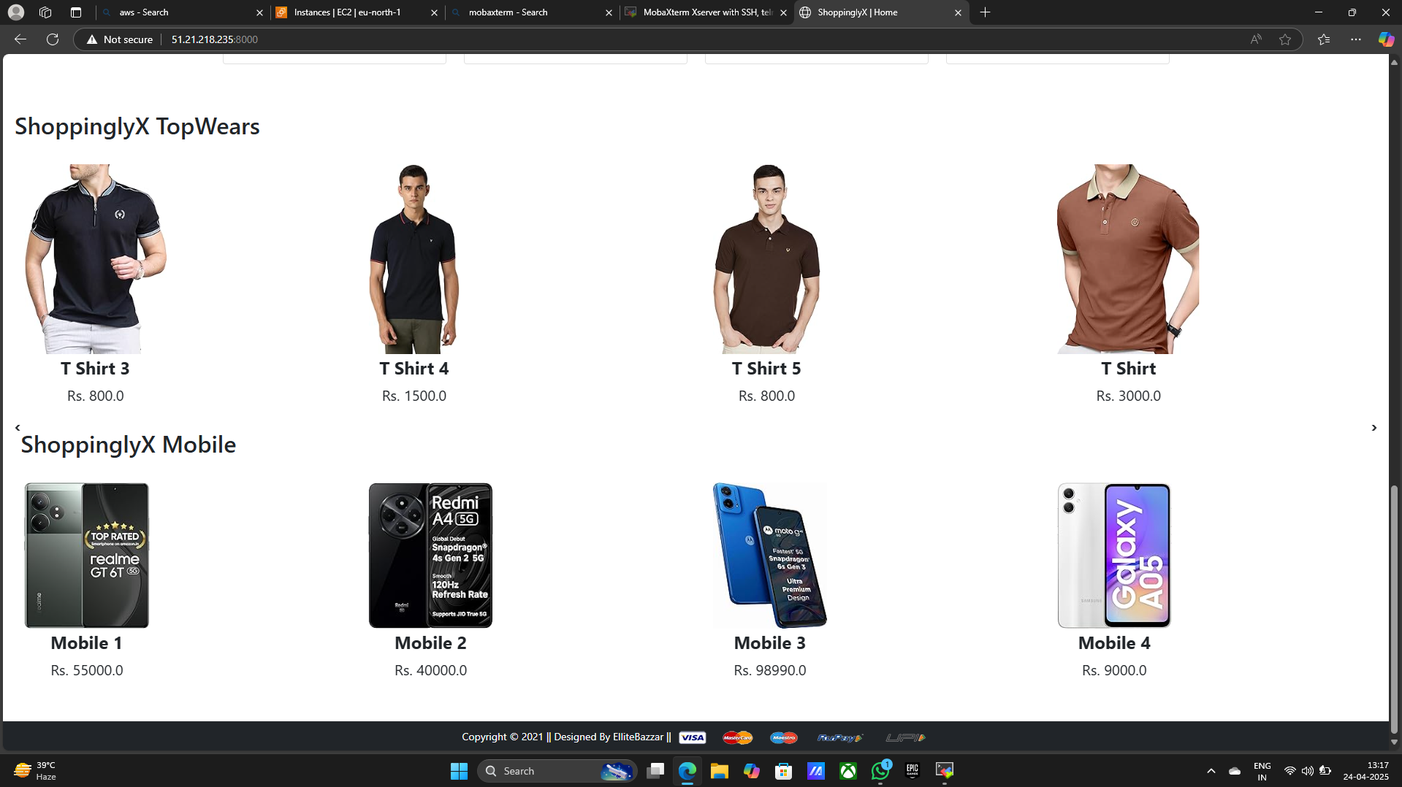

**Precautions:**

**• Keep AWS keys secret and secure.**

**• Use VPC to isolate your network.**

**• Allow only needed ports (like 80, 443, 22).**

**• Use HTTPS for secure data transfer.**

**• Store files in S3, not on the server.**

**• Backup your database regularly.**

**• Watch your AWS usage to avoid high bills.**

**• Use monitoring tools like CloudWatch.**

**Conclusion:**

**Deploying an eCommerce Django website like "Main Vishal ZIP Code Hosting" on AWS offers flexibility, scalability, and control. By leveraging AWS services such as EC2, VPC, S3, and RDS, the platform can efficiently serve users based on ZIP code-specific data. However, secure and well-structured architecture is crucial to ensure data protection, system reliability, and cost-effectiveness. With proper precautions, the project is well-positioned for growth, high availability, and performance at scale.**